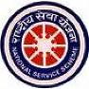
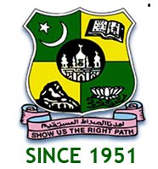 JAMAL MOHAMED COLLEGE (AUTONOMOUS)
Accredited (3rd Cycle) with ‘A’ Grade by NAAC
(Affiliated to Bharathidasan University)
Tiruchirappalli-620 020
NATIONAL SERVICE SCHEME
REGULAR ACTIVITY
FRESHER’S DAY
On the date of 17th June 2019, the Fresher’s Day programme was celebrated by the Management of Jamal Mohamed College. The grand Inauguration function took place at The A/C Auditorium of Jamal Mohamed College by 09.00 a.m. The entire fresher’s were warmly welcomed by the Management and Staff members and the students. Sweets were distributed for the fresher’s. I took part in this Fresher’s Day programme.
DATE : 17/06/2019
VENUE : A/C AUDITORIUM
HOURS : 3 hrs TIME : 9:00 AM to 12:00 PM
CHIEF GUEST: JMC MANAGEMENT COMMITTEE MEMBERS
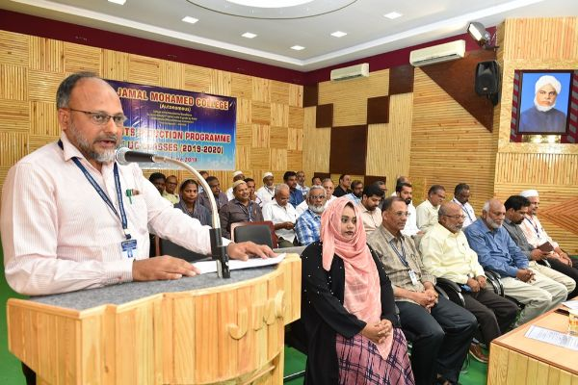

ONE STUDENT ONE TREE-PLEDGE
On the date of 17th June 2019, the Fresher’s Day programme was celebrated by the Management of Jamal Mohamed College. On that time students where taken pledge on ONE STUDENT ONE TREE. I have also participated in that pledge.
Number of NSS Volunteers Participated: 25 DATE :17/06/2019
VENUE : JAMAL MOHAMED COLLEGE
HOURS :3 hr TIME : 12:00 AM to 3:00 PM
CHIEF GUEST : JMC MANAGEMENT COMMITTEE MEMBERS
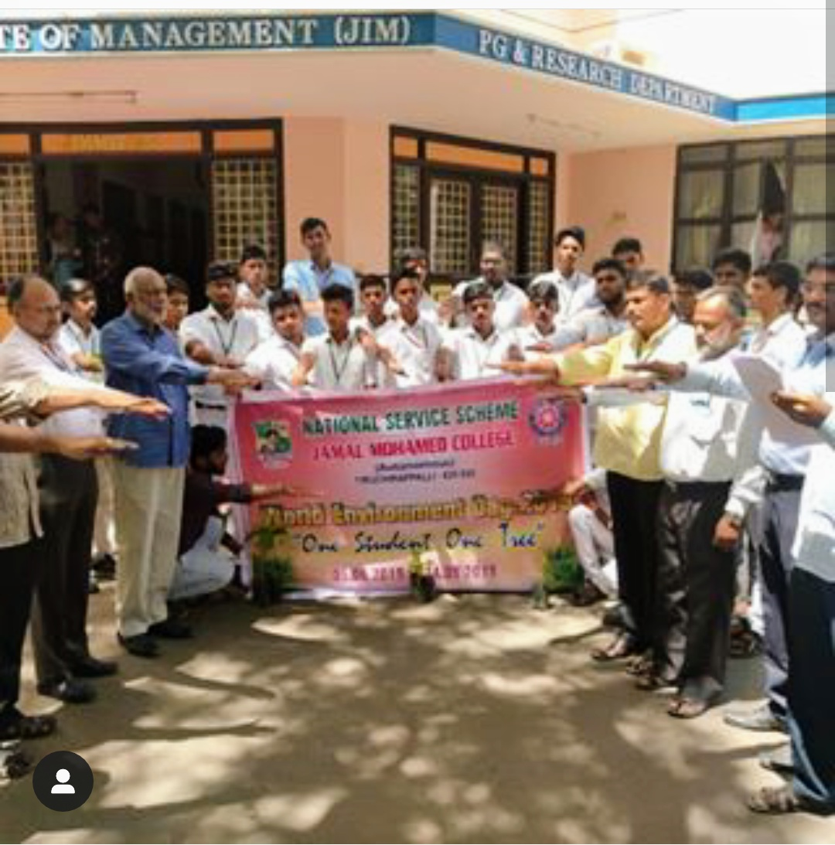
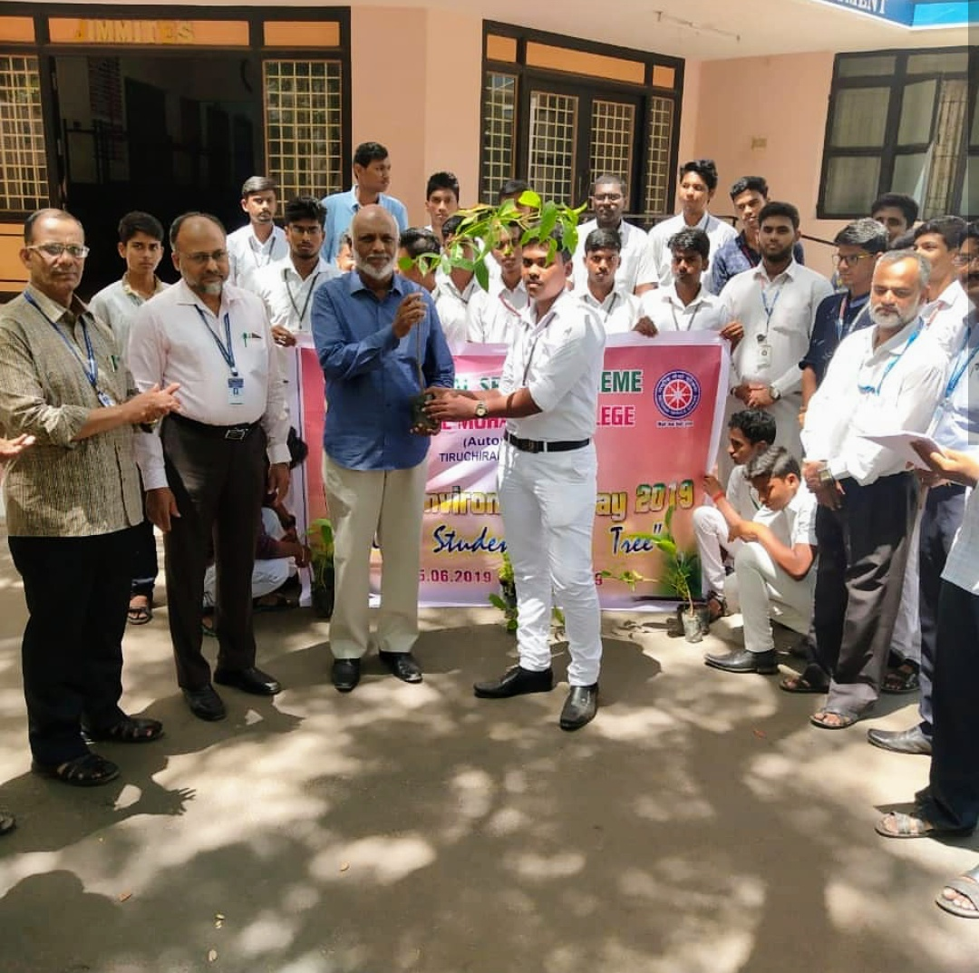
INTERNATIONAL DAY OF YOGA CELEBRATIONS @ BDU
On the date of 21/06/2019, The International Day of Yoga was celebrated by the NSS Cell of Bharathidasan University in association with the NSS units of other colleges in Kajamalai Campus at Bharathidasan University.
He did many Yoga Postures and also made the volunteers do some easy postures. I have also done some Yoga Postures. The programme was a mass success because of the co-ordination of volunteers.
Number of NSS Volunteers Participated:70 DATE :21/06/2019
VENUE : KHAJAMALAI BDU CAMPUS
HOURS :3 hrs TIME : 6:30 AM to 9:30 AM
CHIEF GUEST: Vice chancellor of BDU - Dr. MANISANKAR
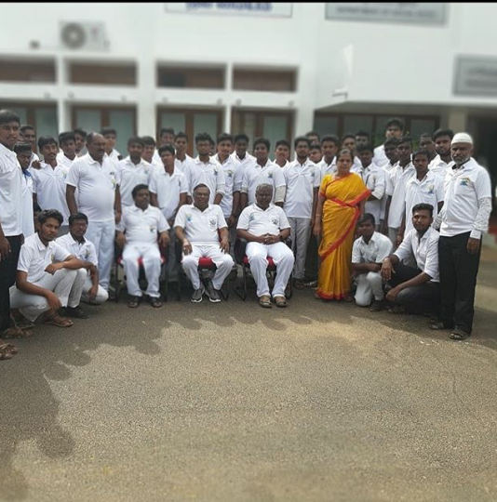
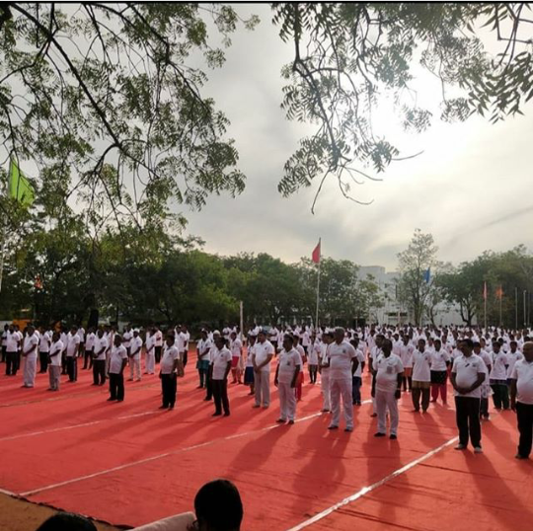

INTERNATIONAL DAY OF YOGA @ JMC
On the date of 21/06/2019, The International Day of Yoga was celebrated by Our College, organized by NSS Units of JMC at Multi Purpose Indoor stadium of our campus. I have also participated and done some Yoga Postures.
Number of NSS Volunteers Participated:170 DATE :21/06/2019
VENUE : INDOOR STADIUM, JMC
HOURS :4 hrs TIME : 10:00 AM to 02:00 PM
CHIEF GUEST : GANESAN.M and A.PALANISAMY
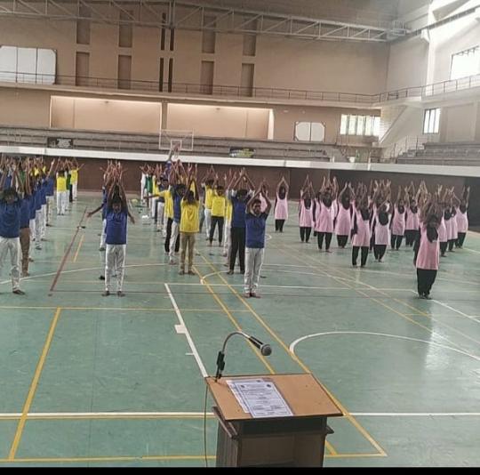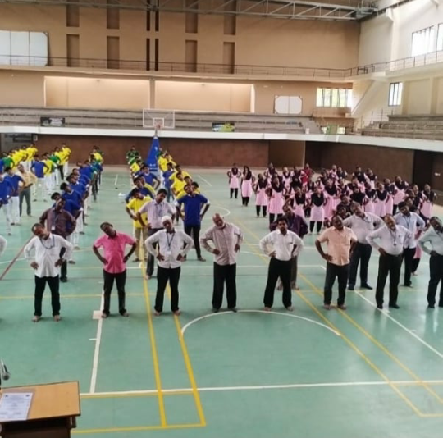

TOBBACO AWARENSS RALLY
On the date of 26th June 2019, Tobbaco Awareness programme was and also awaking our Trichirapalli people those are have and good experience. I interacted with the public people and create awareness. It is an excellent and helpful rally for Trichirapalli people. The programme was great success.
Number of NSS Volunteers Participated: 40 DATE :26/06/2019
VENUE : Vestrey’s school
HOURS : 3 hrs TIME : 08:30 AM to 11:30 AM
CHIEF GUEST : COLLECTOR SIVARASU
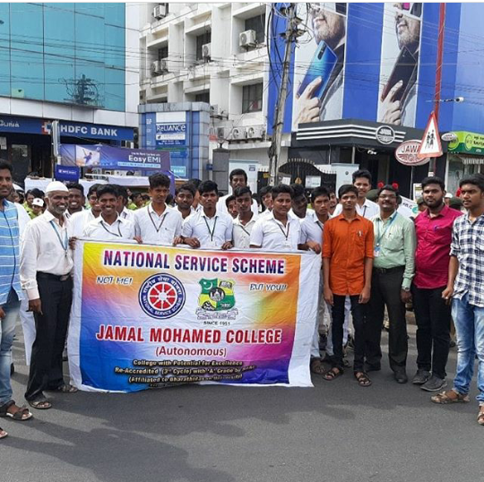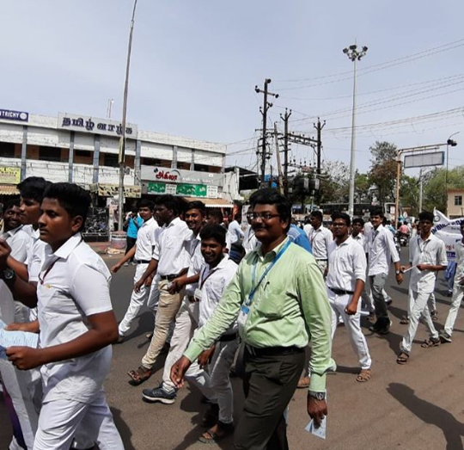
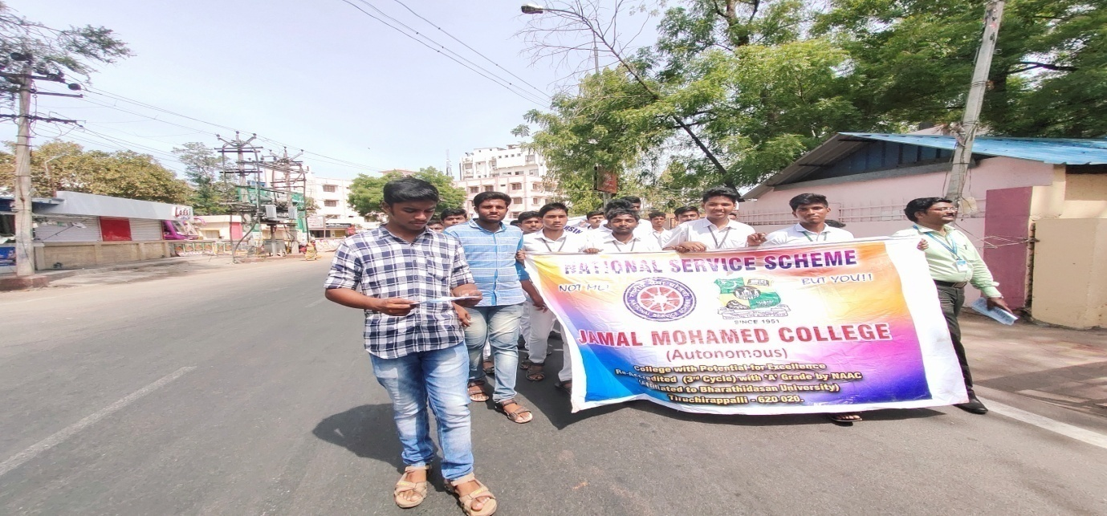

WORLD POPULATION DAY RALLY
On the date of 11/07/2019, World Population Rally was conducted by Public Health Department Govt. of Tamilnadu in association with the NSS units of our colleges. The programme was great success.
Number of NSS Volunteers Participated: 50 Date: 11.07.2019
VENUE: Government Medical College Campus, Trichy
HOURS: 3 hrs TIME:12.30 PM to 3.30PM

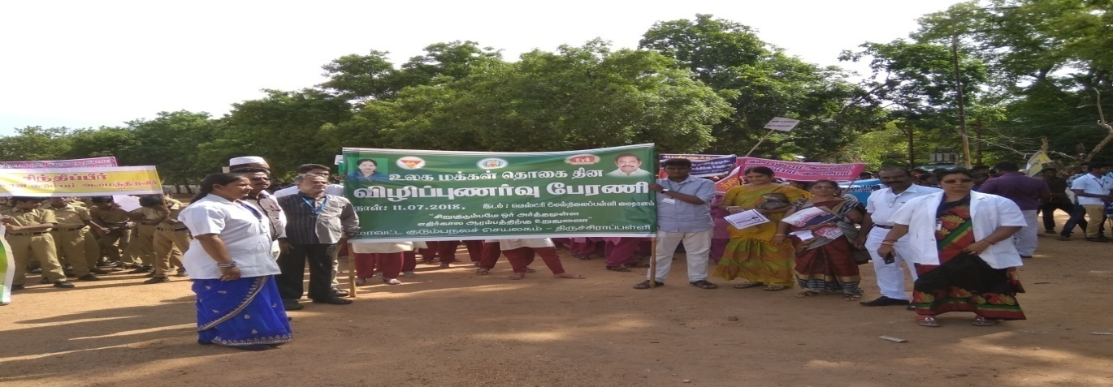

WORLD POPULATION DAY – OATH
On the date of 11/07/2019, WORLD POPULATION DAY – OATH was taken by our NSS VOLENTEER’S along with Faculty members in front of Auditorium of Our College. I have also taken oath.
The programme was a mass success because of the co-ordinator of volunteers.
Number of NSS Volunteers Participated: 50 Date: 11.07.2019
VENUE:JAMAL MOHAMED COLLEGE
HOURS: 2 hr TIME:12.30AM to 2.30PM
CHIEF GUEST:THE SECRETARY,PRINCIPAL& TRESURER

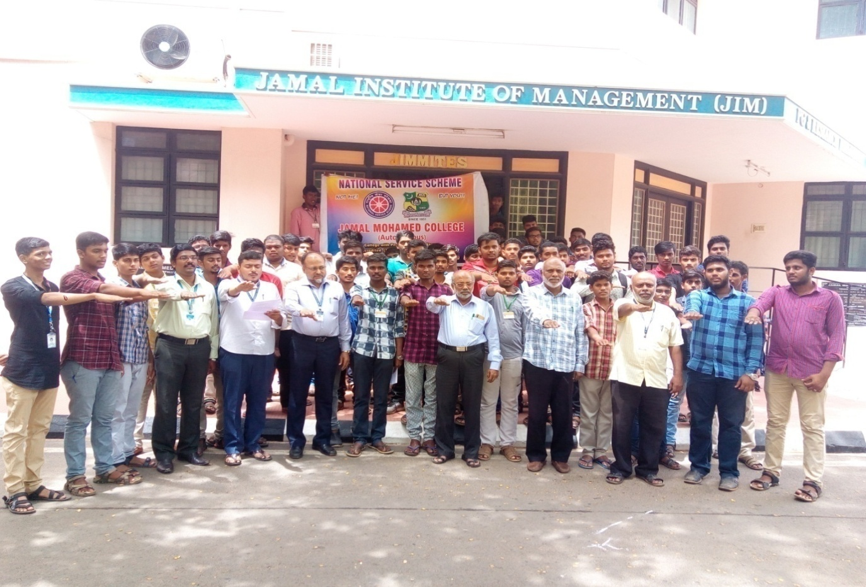

FOUNDERS DAY
On the date of 11/07/2019, the Founder’s Day programme was celebrated by the Management of Jamal Mohamed College. The grand Founders function took place at The A/C Auditorium of Jamal Mohamed College by 09.00 a.m. Founders day celebrated with Management and Staff members and the students. Sweets were distributed for the all.

Number of NSS Volunteers Participated: 30 Date: 11.07.2019
VENUE:JAMAL MOHAMED COLLEGE
HOURS:9hrs TIME:9.00AM to 6.00PM
CHIEF GUEST: ACTOR PALAKARUPAIYA
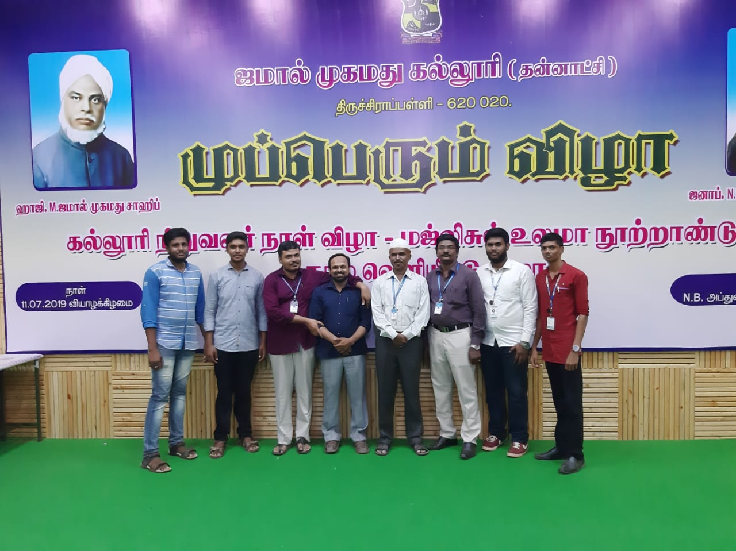

RAINWATER HARVESTING RENOVATIONWORK
On the date of 16/07/2019, CAMPUS CLEANING PROGRAMME was Conduct by the NSS VOLENTEER’S in JMC.
The programme was a mass success because of the co-ordinator of volunteers.
NO. OF PARTICIPANT: 15 DATE 16/07/2019
VENUE : JMC AND HOSTEL
HOURS:5 Hr TIME:8.30 AM to 1.30PM
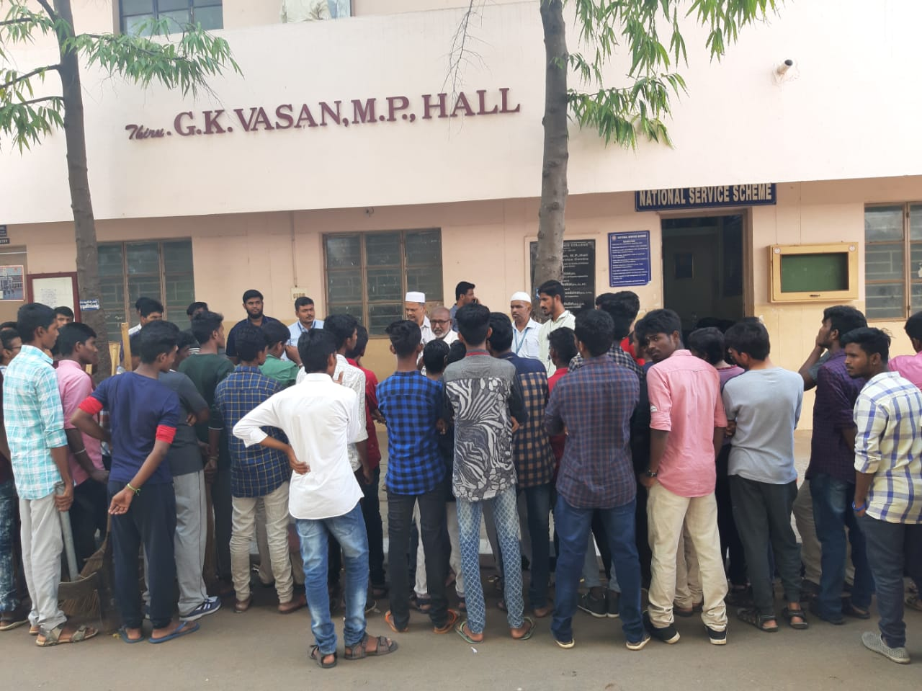
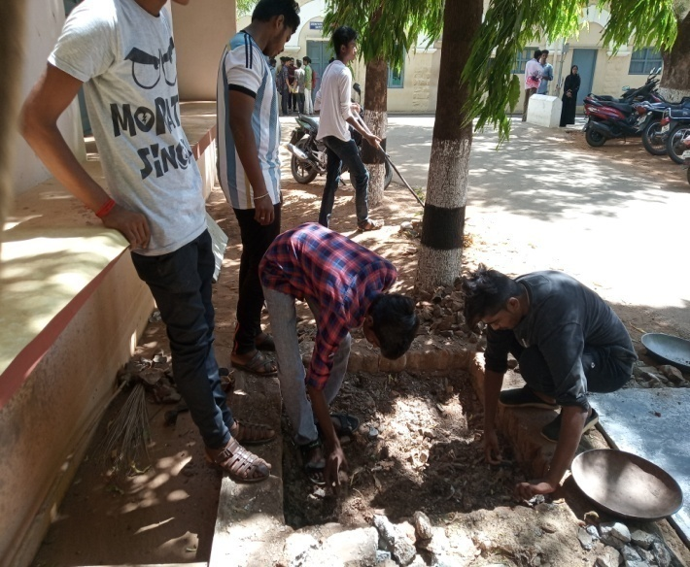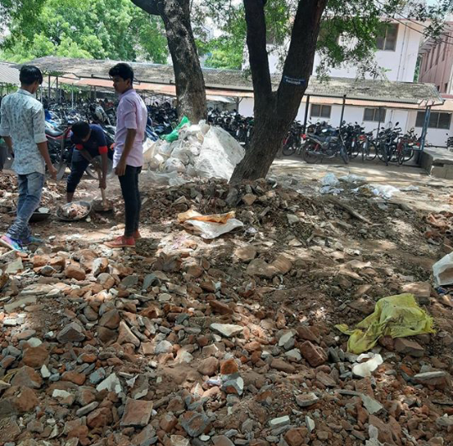

JOB FAIR PROGRAMME

On the date of 27/07/2019, JOB FAIR PROGRAMME was celebrated by the NSS VOLENTEER’S in JAMAL MOHAMED COLLEGE at MINNA BLOCK.
The programme was a mass success because of the co- ordination of volunteers.
NO. OF PARTICIPANT :20 DATE :27/07/2019
VENUE : MINNA BLOCK
HOURS :7 hrs TIME : 08:30 AM to 2:00
CHIEF GUEST : TRICHY DISTRICT COLLECTOR
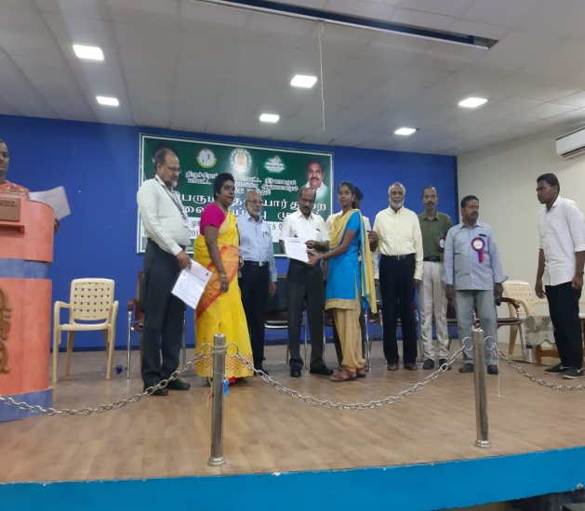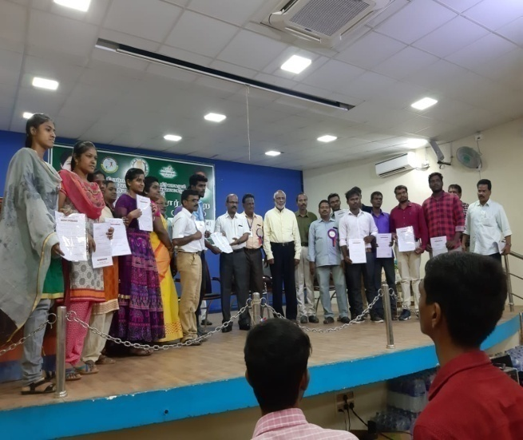
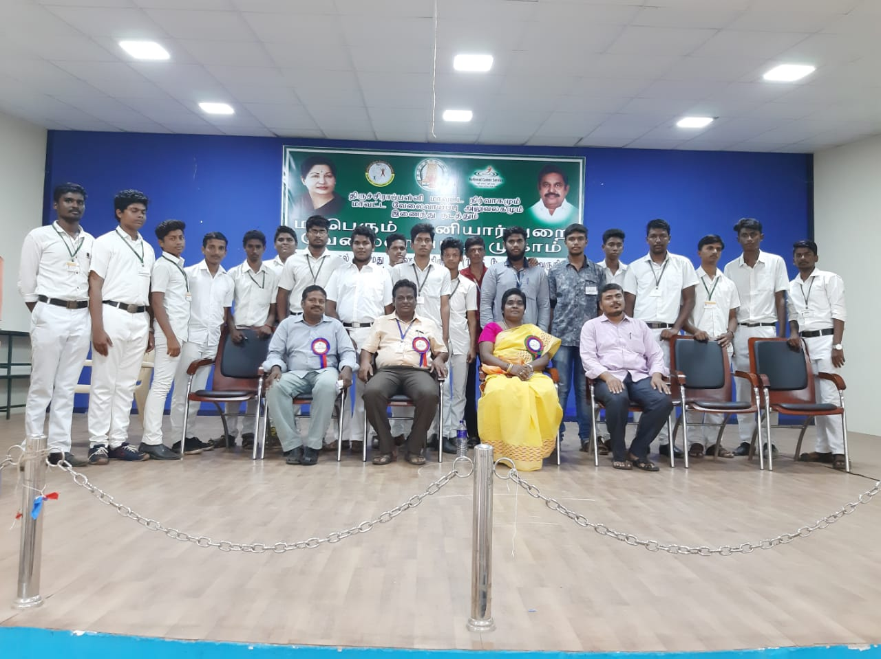

COLLEGE LEVEL PRE-RD TRAINING
On the date of 25.07.2019, 26.07.2019, 29.07.2019 and 30.07.2019, COLLEGE LEVEL PRE-RD TRAINING PROGRAMME was Conduct by the NSS VOLUNTEER’S in JMC.
The programme was a great success.
NO. OF PARTICIPANTS: 90
DATE : 25.07.2019, 26.07.2019, 29.07.2019 and 30.07.2019
VENUE : JMC AND HOSTEL
HOURS: 20 Hr 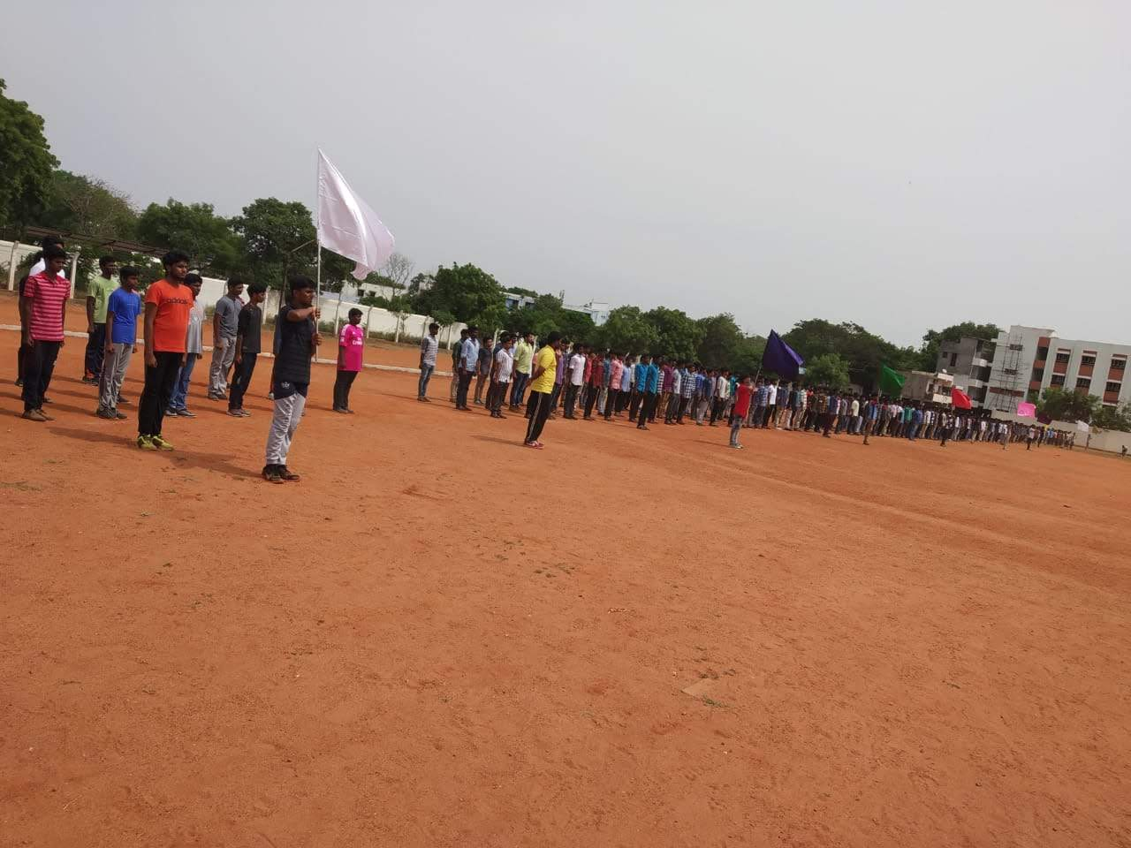
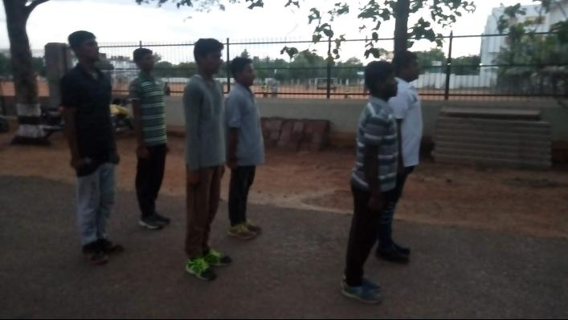

HOSPITAL DAY CELEBRATION
On the date of 30/07/2019, HOSPITAL DAY CELEBRATION was conducted by the HELPING HANDS OF JAMAL MOHAMED COLLEGE AND GOVERNMENT MEDICAL COLLEGE
NO. OF PARTICIPANT : 20 DATE :30/07/2019
VENUE : GOVERNMENT MEDICAL COLLEGE
HOURS : 3 hrs TIME : 08:30 AM to 11:30 AM
CHIEF GUEST : Principal Dr.S.ISMAIL MOHIDEEN
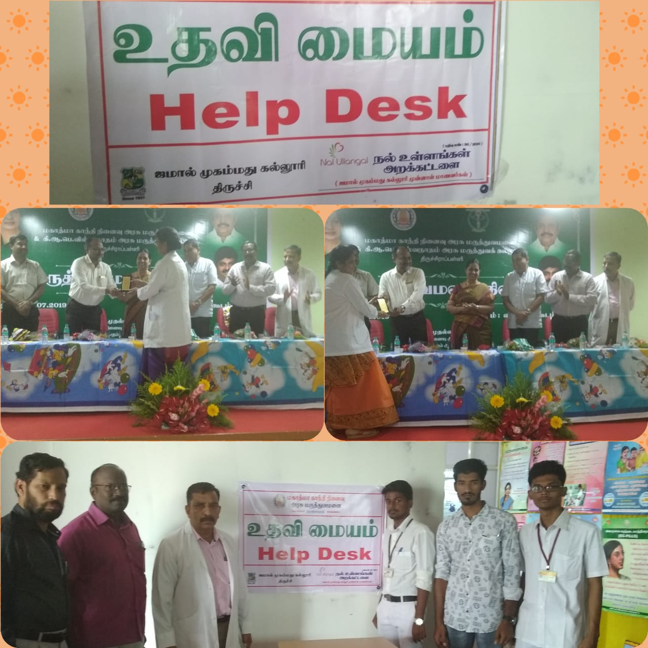
ANNUAL SPORTS MEET
On the date of 31/07/2019, SPORTS DAY FUNCTION was celebrated by the NSS VOLENTEER’S in JMC , College ground
The programme was a mass success because of the co-ordinator of volunteers.
NO. OF PARTICIPANT : 120 DATE : 31/07/2019
VENUE : JMC , College ground
HOURS :5 hr TIME : 09:00AM to 02:00 PM
CHIEF GUEST: G.NISAR BASHA IRS
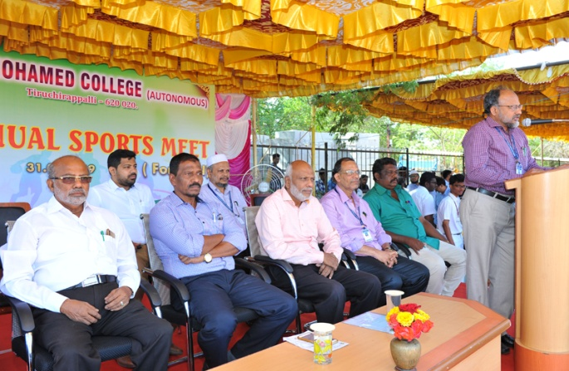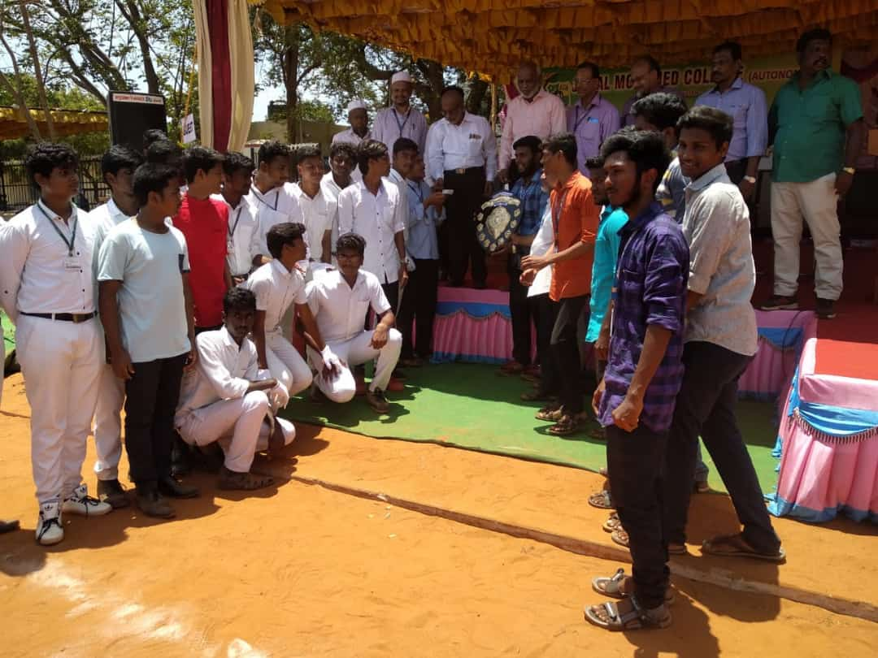
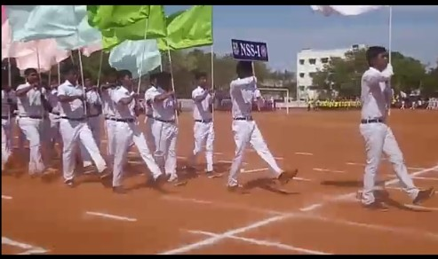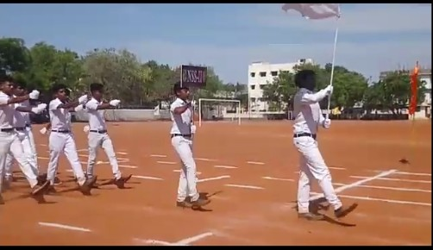
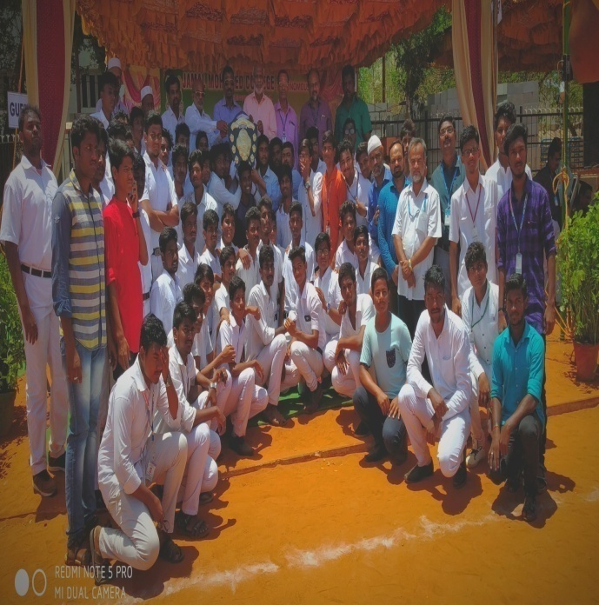

SWACCHH PAKWARA OATH
On the date of 01/08/2019, SWACCHH PAKWARA OATH was taken by our NSS VOLENTEER’S along with Faculty members in front of Auditorium of Our College.
NO. OF PARTICIPANT : 80 DATE :01/08/2019
VENUE : JMC
HOURS : 5 hrs TIME : 08:30 AM to 1:30PM
CHIEF GUEST : Principal Dr.S.ISMAIL MOHIDEEN
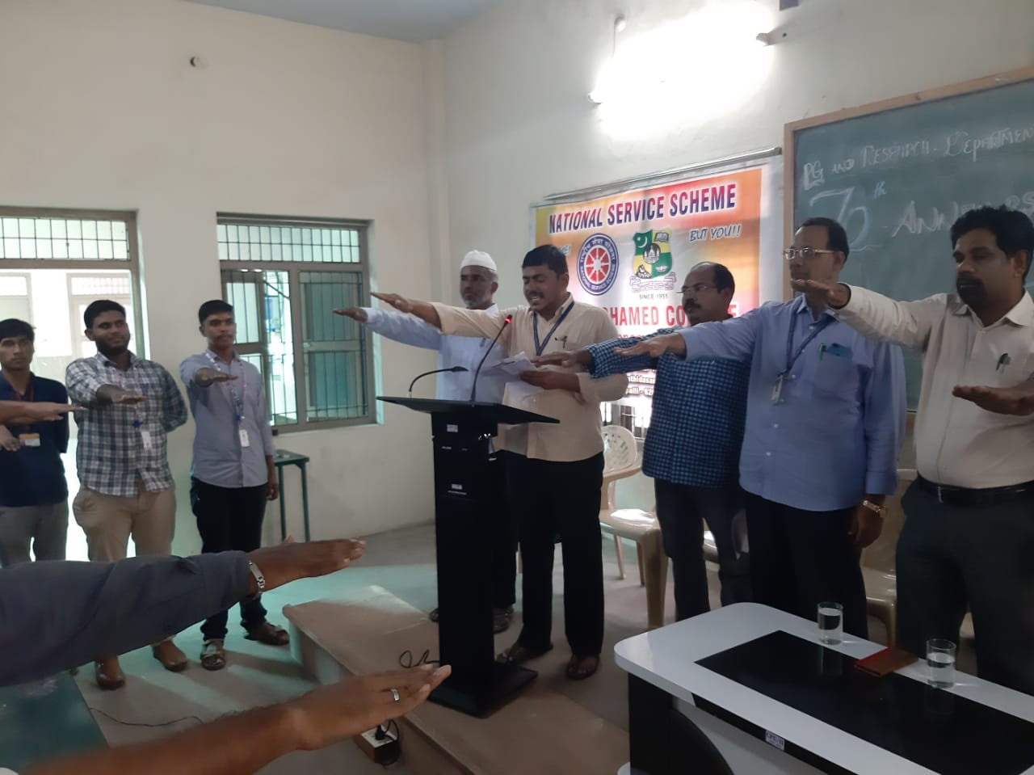
SWACCHH PAKWARA-2019
COLLEGE CAMPUS CLEANING
On the date of 02/08/2019, CAMPUS CLEANING PROGRAMME was celebrated by the NSS VOLUNTEERS in JMC.

NO. OF PARTICIPANT : 35 DATE : 02/08/2019
VENUE : JMC MOSQUE TIME:9:30AM to 1:30PM
HOURS:4hrs
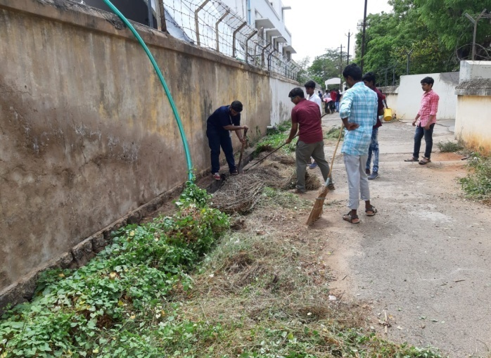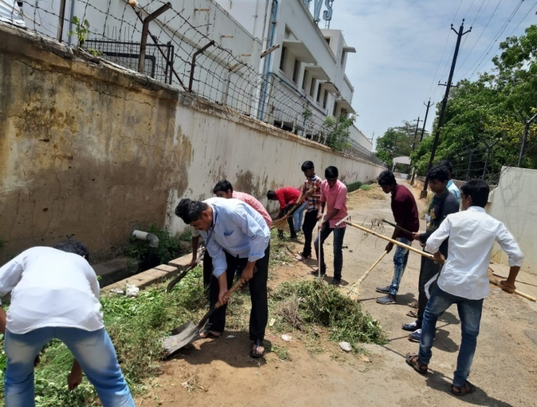

TRICHY PLOGGING
On the date of 03/08/2019, Trichy Plogging was conduct by the Trichy Municipality at Anna Stadium.
The programme was a grand success.
NO. OF PARTICIPANT : 35 DATE : 03/08/2019
VENUE : Anna Stadium
HOURS :2 hrs TIME : 06:30AM to 08:30 AM
CHIEF GUEST: TRICHY CITY CORPORATION COMMISSIONER
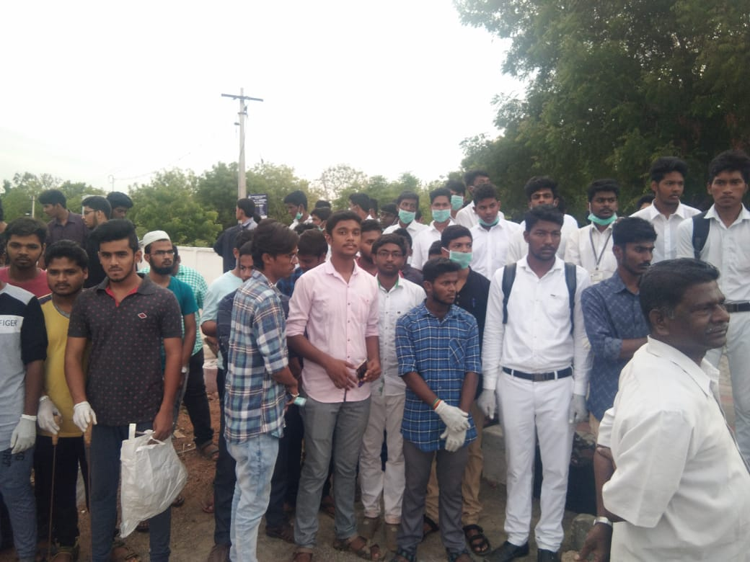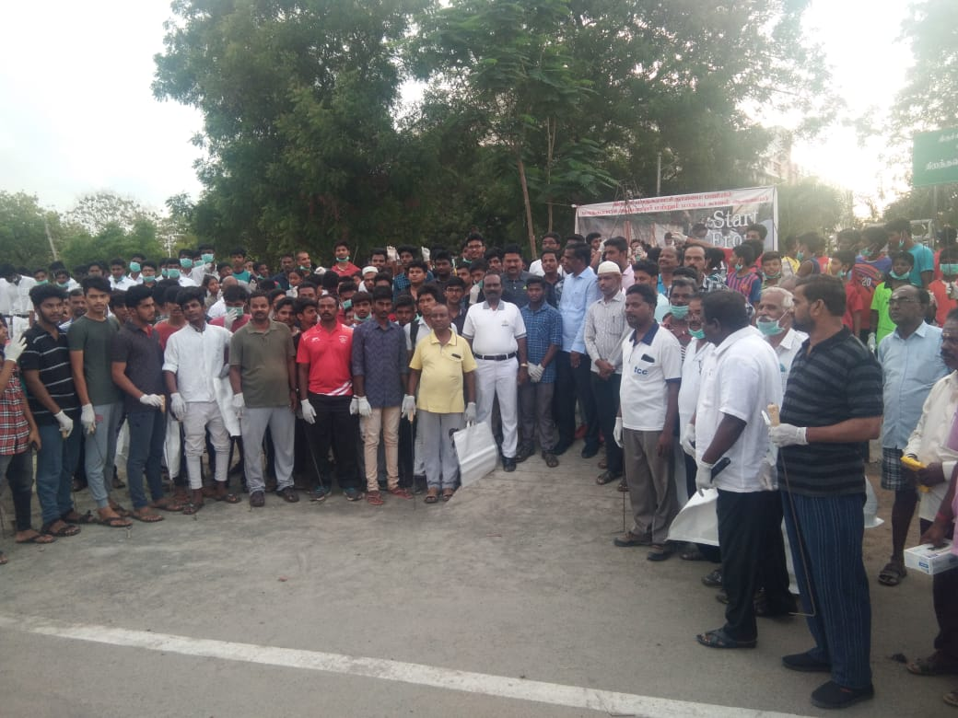
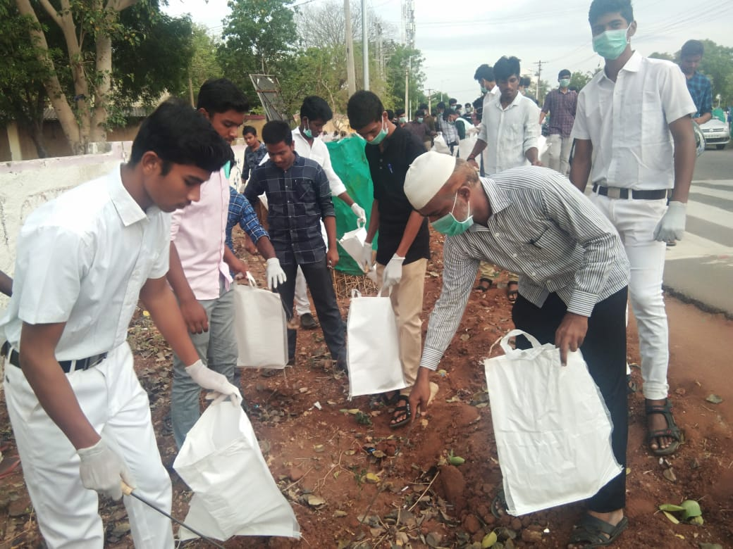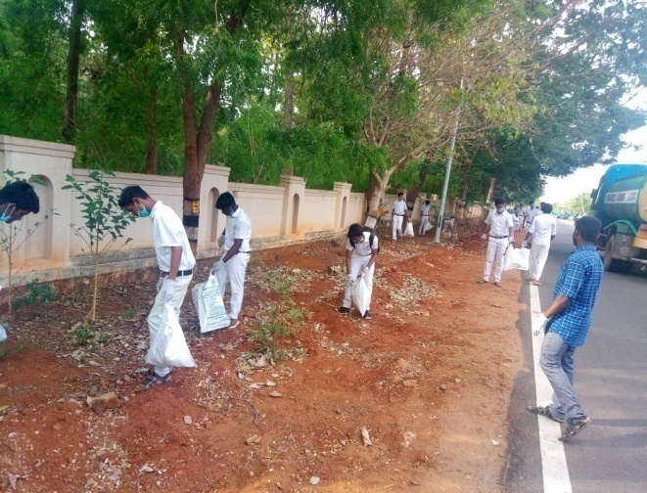

SWACCHH PAKWARA 2019
COLLEGE MOSQUE CLEANING
On the date of 03/08/2019, CAMPUS CLEANING PROGRAMME was conducted by the NSS VOLENTEER’S in JMC- Mosque.
The programme was a mass success because of the co-ordinator of volunteers.
NO. OF PARTICIPANT : 50 DATE : 03/08/2019
VENUE : JMC MOSQUE TIME:9:30AM to 1:30PM
HOURS:4hrs
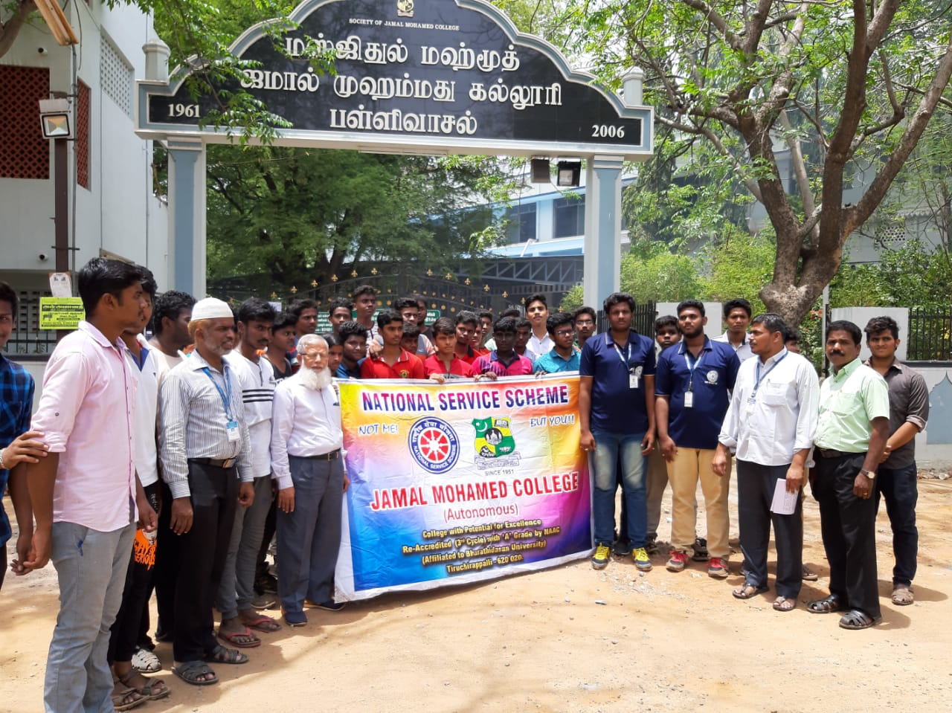
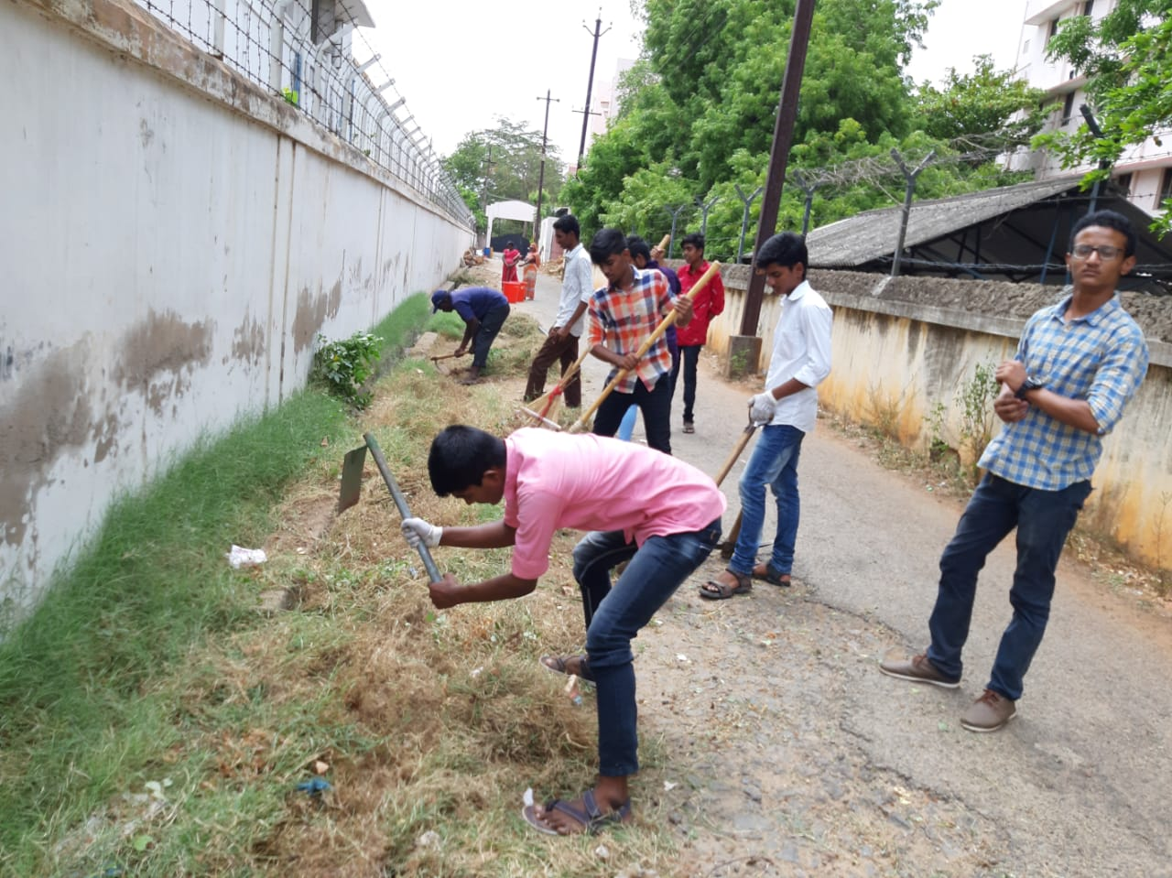
SWACCHH PAKWARA
CLASS ROOMS CLEANING
On the date of 05.08.2019 SWACCHH PAKWARA CLASS ROOMS CLEANING PROGRAMME conducted by NSS Volenteer’s at our college campous.
NO. OF PARTICIPANT : 10 DATE :05/08/2019
VENUE : MINNA BLOCK
HOURS : 4 hr TIME : 12:00 AM to 4:00 PM
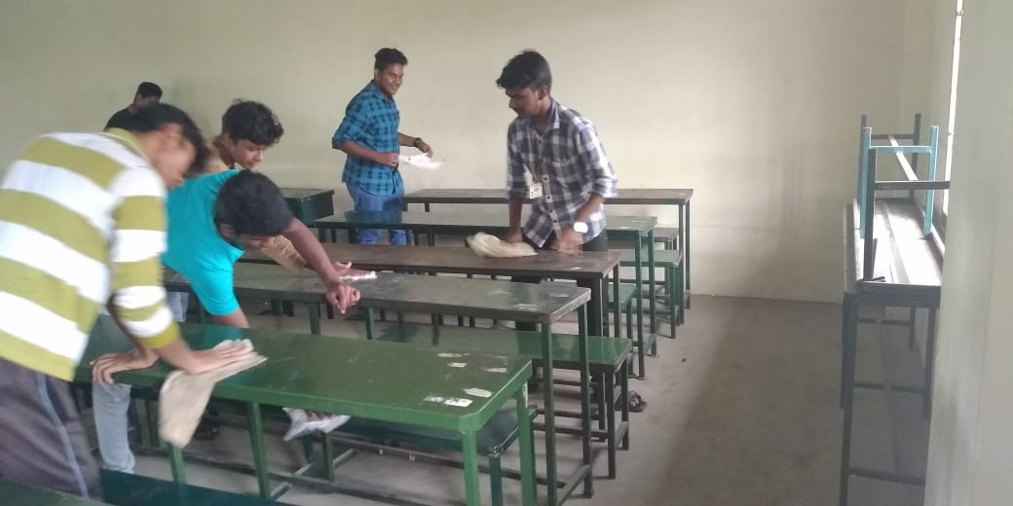
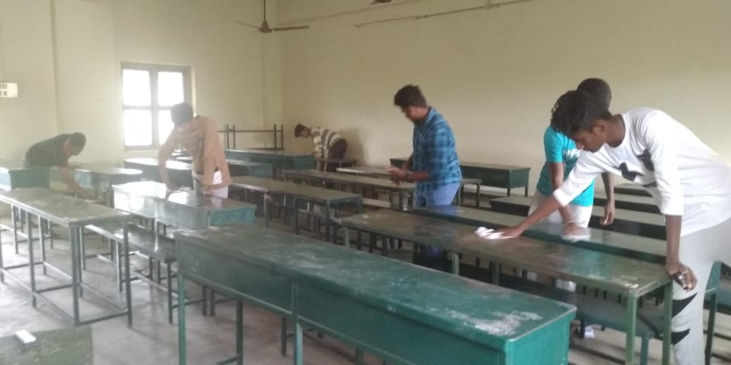

SWACCHH PAKWARA-2019
LIBRARY CLEANING
On the date of 06.08.2019 SWACCHH PAKWARA 2019 LIBRARY CLEANING PROGRAMME conducted by NSS Volenteer’s at our college campous.
NO. OF PARTICIPANT : 10 DATE :06/08/2019
VENUE : JMC
HOURS :4 hr TIME : 01:30 PM to 5:30PM
s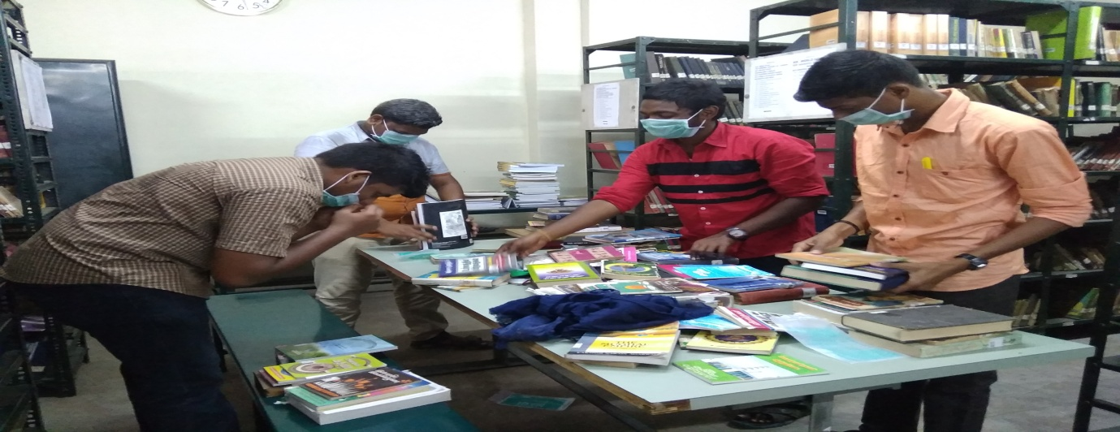
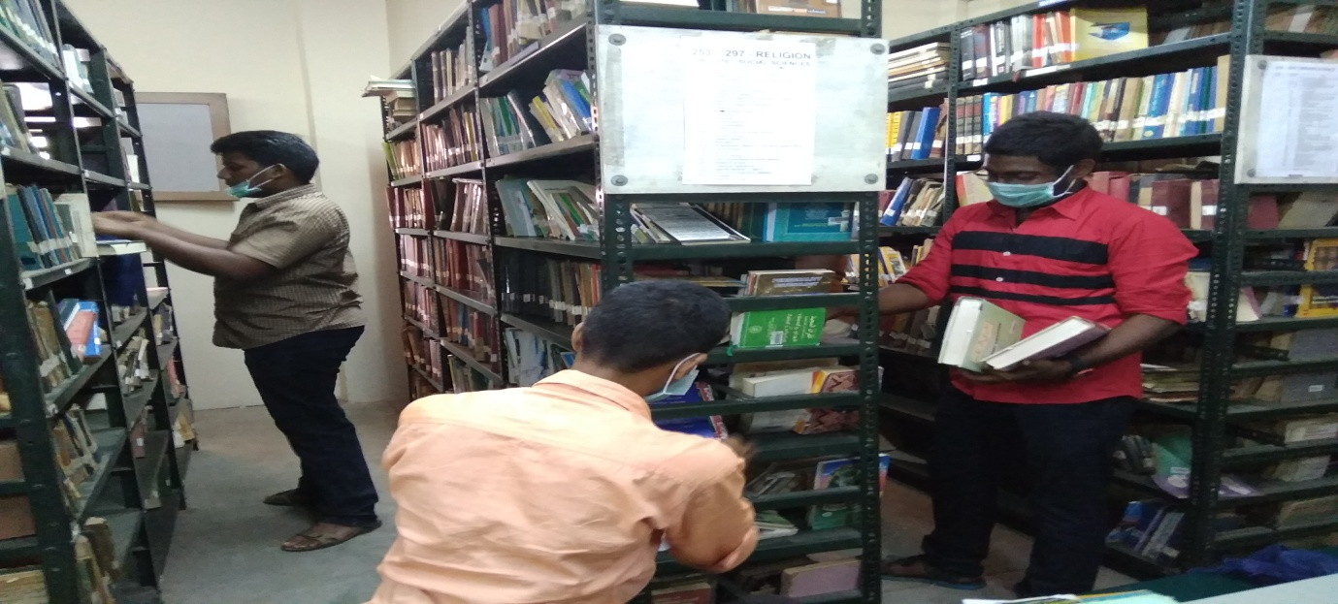

NATIONAL DEWORMING DAY AND MOP UP DAY
On the date of 08.08.2019 NATIONAL DEWORMING DAY AND MOP UP DAY Was conducted by Public Health Department and NSS wing of Jamal Mohamed college at our college campous.
NO. OF PARTICIPANT : 10 DATE :08/08/2019
VENUE : JMC
HOURS : 8 hr TIME : 08:30 AM to 2:00 PM
CHIEF GUEST : Principal Dr.S.ISMAIL MOHIDEEN

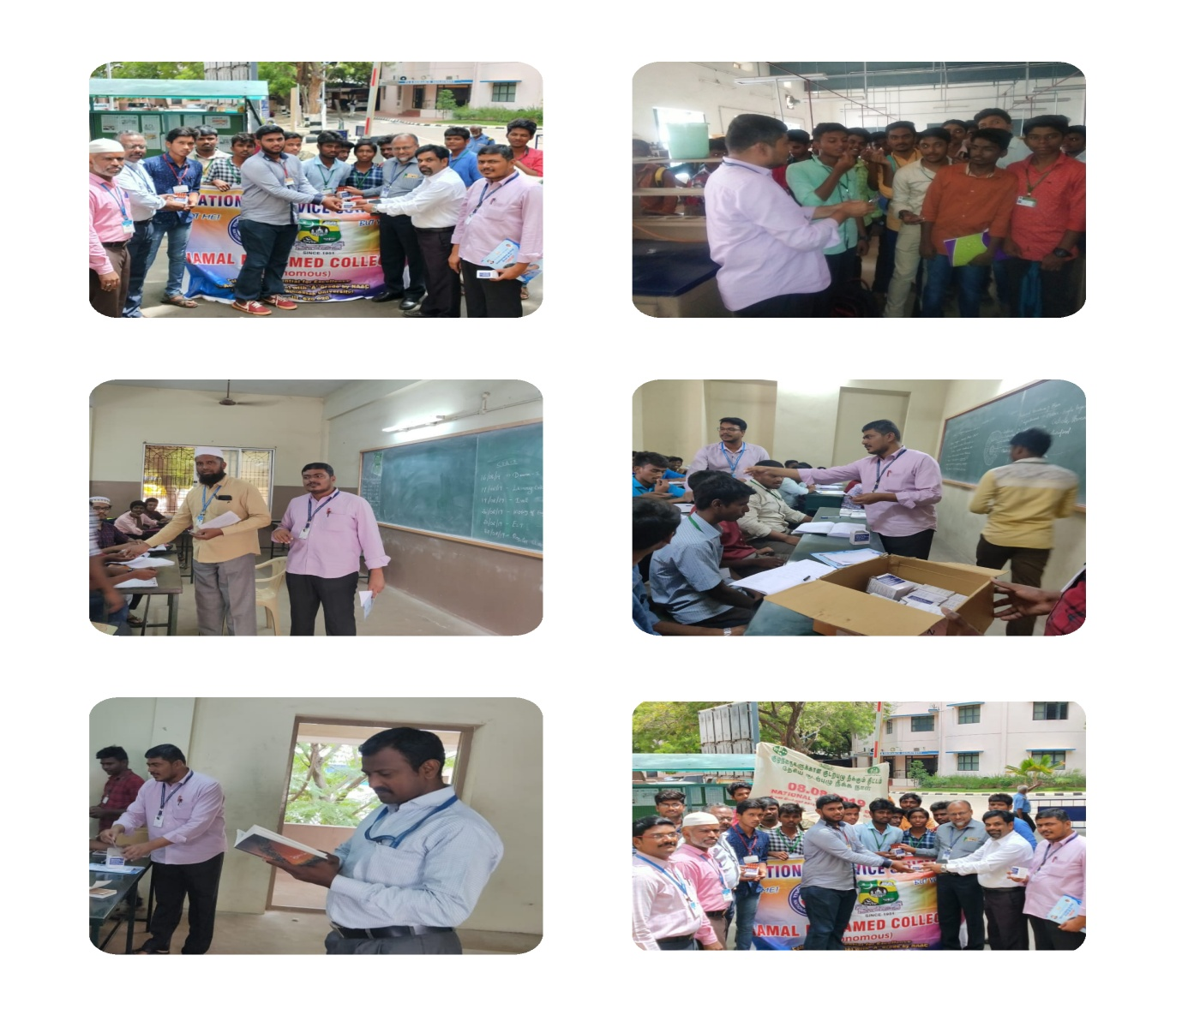

IMAN SCHOLARSHIP
On the date of 09/08/2018, SCOLARSHIP PROGRAMME was celebrated by the NSS VOLENTEER’S in JMC.
The programme was a mass success because of the co-ordinator of volunteers.
NO. OF PARTICIPANT : 04 DATE : 09/08/2019
VENUE : JMC
HOURS :02.00 hrs TIME : 11:00 AM to 01:00 AM
CHIEF GUEST: THE SECRETARY, PRINCIPAL & TRESURER
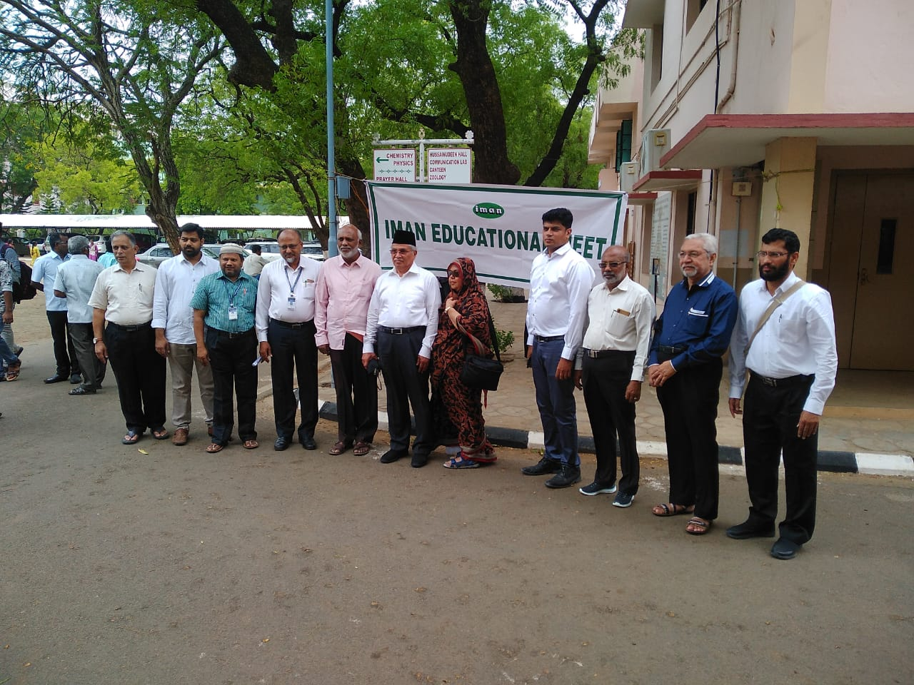
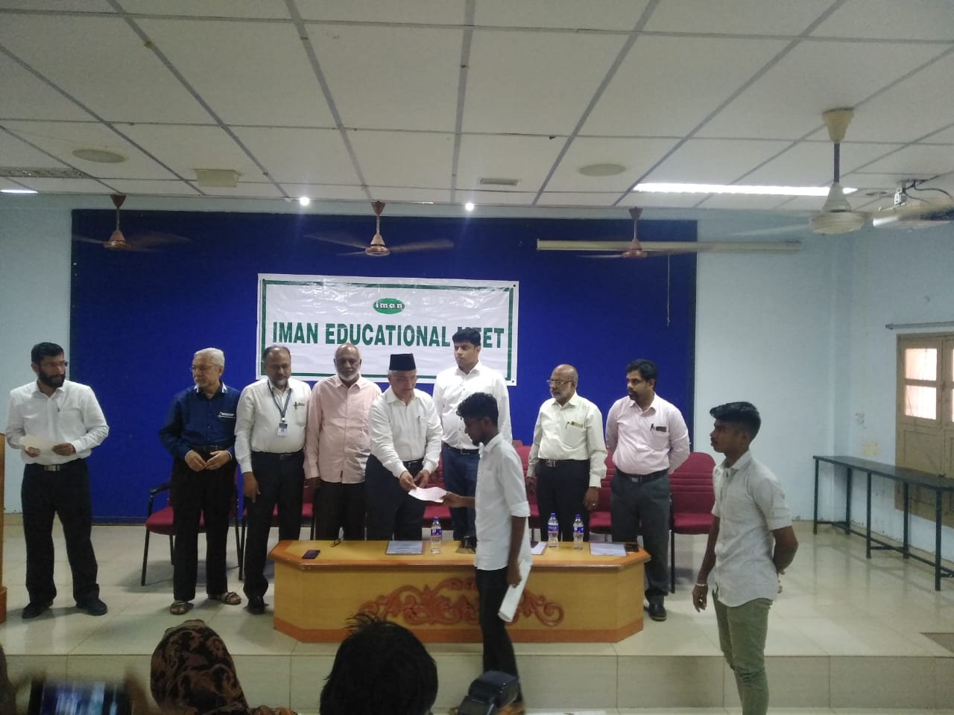

PRE-RD SELECTION
On the date of 13/08/2019, PRE-RD SELECTION was conducted by the NSS VOLUNTEERS in BDU. I have actively participated in that event.

NO. OF PARTICIPANT : 23 DATE :13/08/2019
VENUE : BDU
HOURS :06.00 hrs TIME : 09:00 AM to 03:00 PM
CHIEF GUEST: REGIONAL DIRECTOR GOKULA KRISHNAN
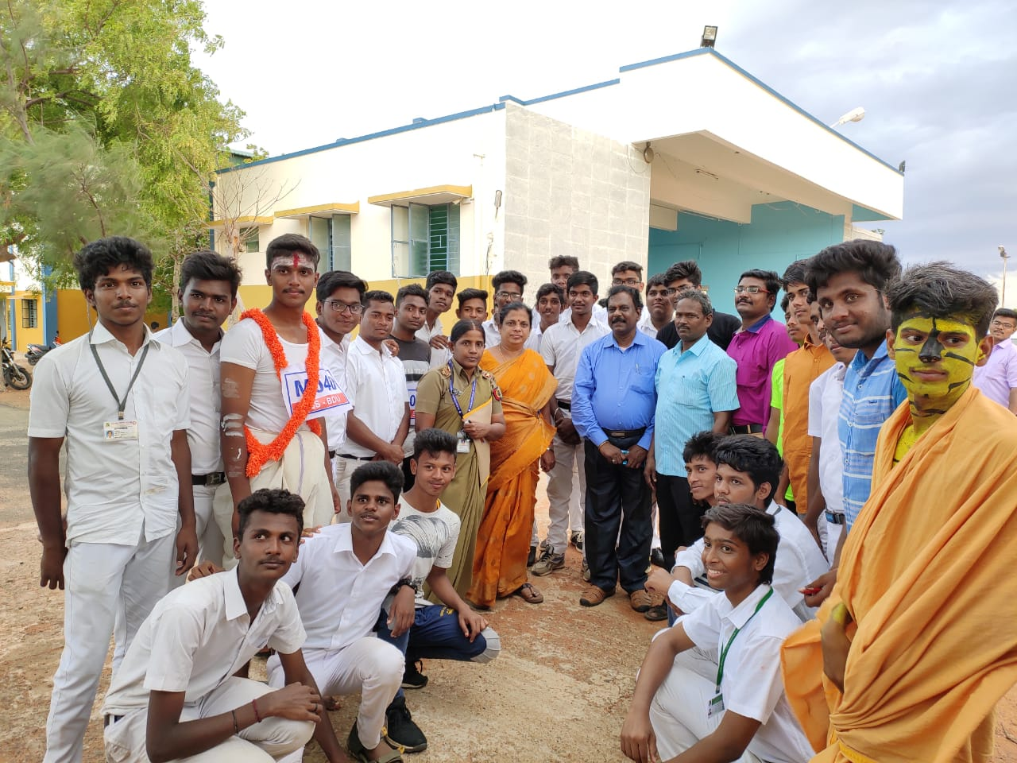

INDEPENDENCE DAY AND ALUMNI MEET
On the date of 15/08/2019, INDEPENDENCE DAY PROGRAMME was celebrated by the NSS VOLENTEER’S in JMC.
NO. OF PARTICIPANT : 75 DATE :15/08/2019
VENUE : JMC
HOURS :02.00 hr TIME : 08:30 AM to 10:30 AM
CHIEF GUEST: THE SECRETARY, PRINCIPAL& TREASURER

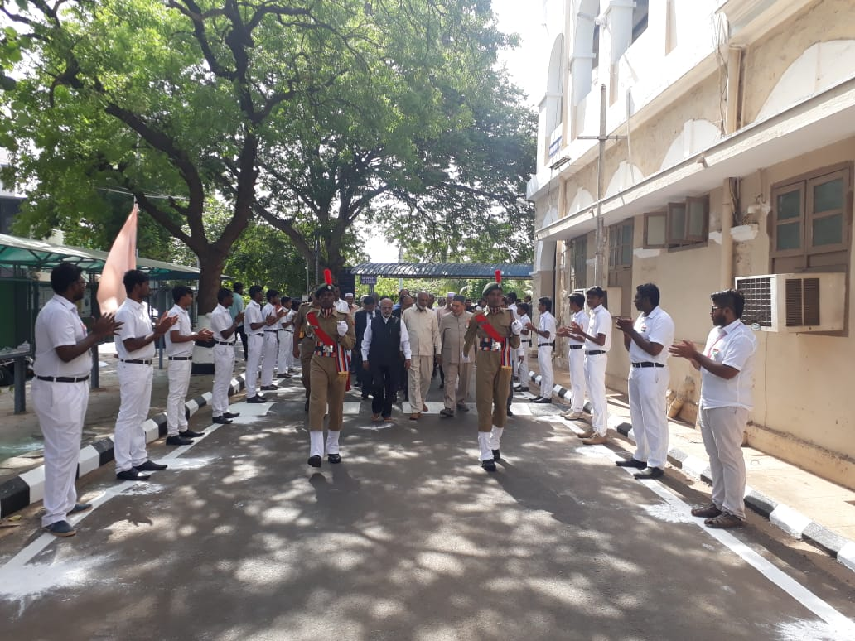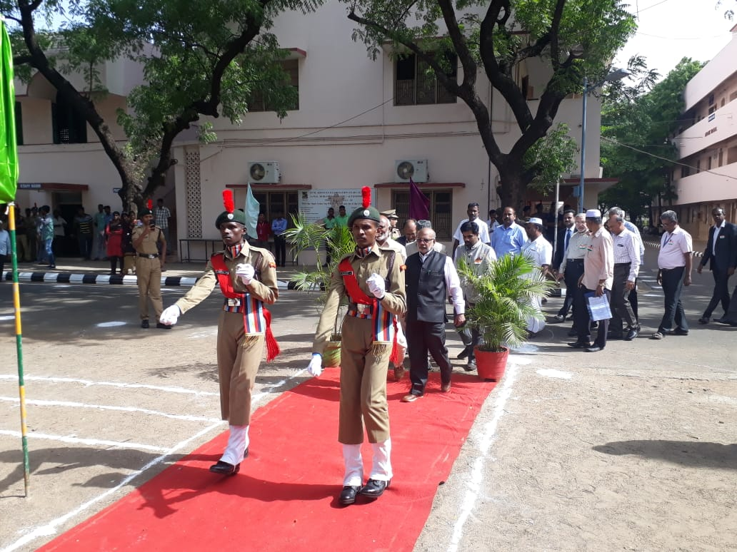

INDEPENDENCE DAY PROGRAMME @ BDU
On the date of 15/08/2019, INDEPENDENCE DAY PROGRAMME was celebrated by the NSS VOLENTEER’S in Bharathidhasan University , Trichy.
The programme was a mass success because of the co-ordinator of volunteers.
NO. OF PARTICIPANT : 25 DATE :15/08/2019
VENUE : BHARATHIDHASAN UNIVERSITY
HOURS :02 hr TIME : 08:30 AM to 10:30 AM
CHIEF GUEST : BDU VICE CHANCELLOR MANI SANKAR

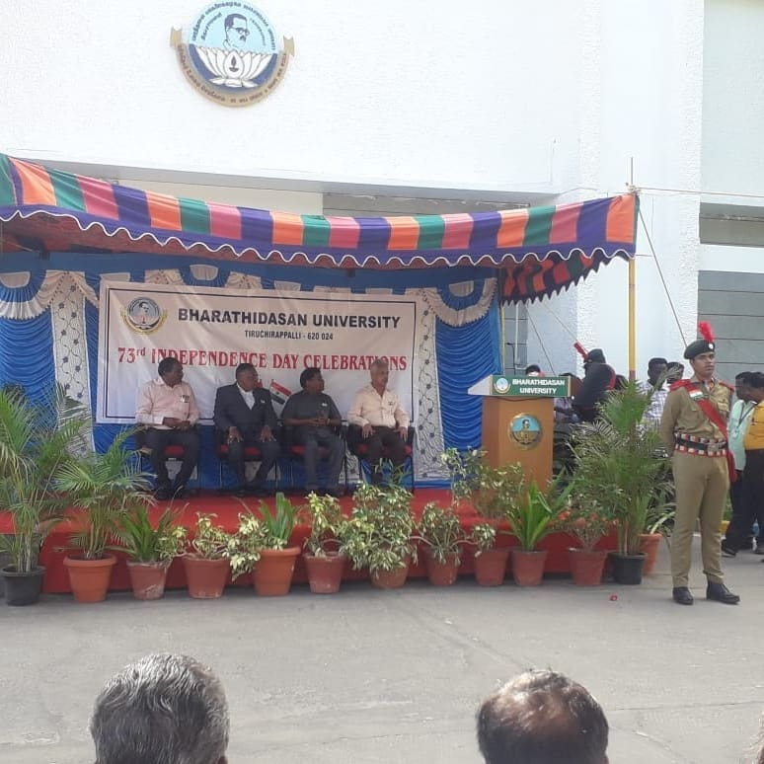
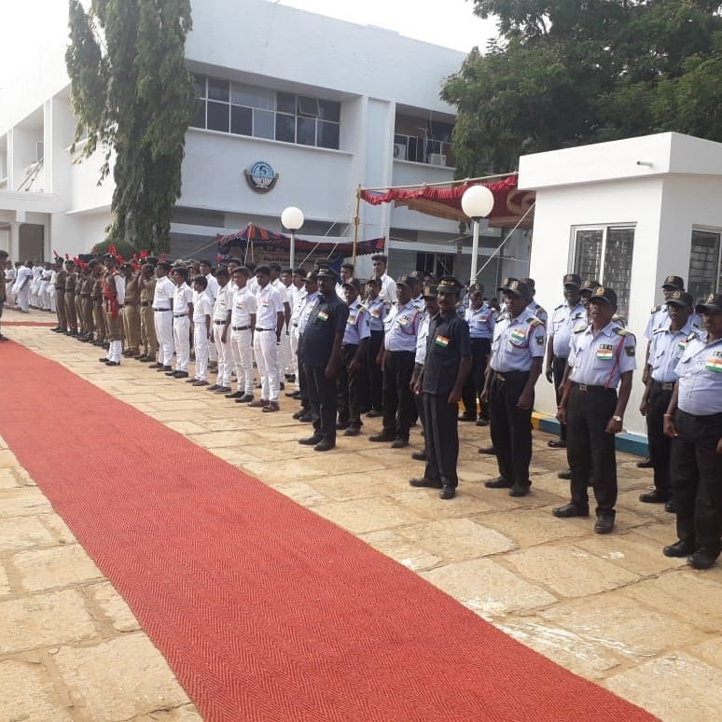
ALUMINI MEET

On the date of 15/08/2018, Alumni Meet was celebrated by the NSS VOLENTEER’S in JMC.
The programme was a mass success because of the co-ordinator of volunteers.
NO. OF PARTICIPANT: 25 DATE :15/08/2019
VENUE : JMC
HOURS: 05.00 hrs TIME : 11:00 AM to 04:00 AM
CHIEF GUEST:
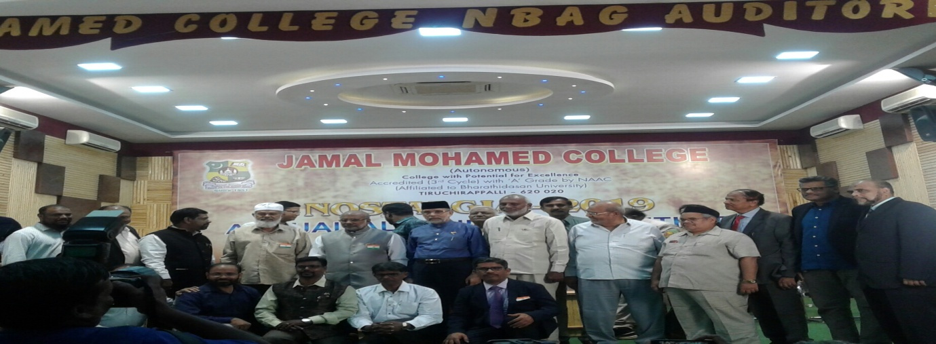
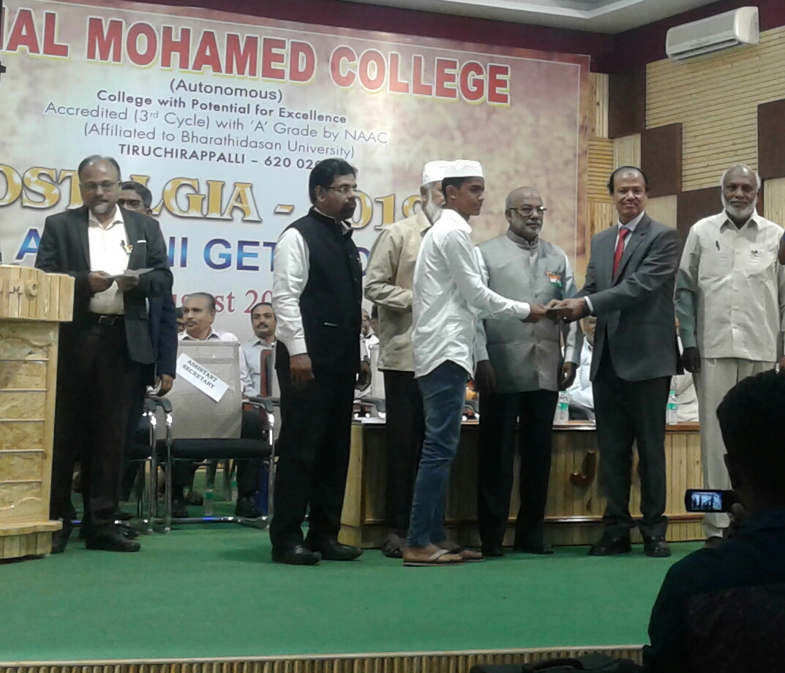

NATIONAL HARMONY DAY
On the date of 20.08.2019 NATIONAL HARMONY DAY was conducted by NSS wing of Jamal Mohamed college at our college campus.
NO. OF PARTICIPANT : 50 DATE :20/08/2019
VENUE : JMC
HOURS :02 hr TIME : 08:30 AM to 10:30 AM
CHIEF GUEST : Principal Dr.S.ISMAIL MOHIDEEN
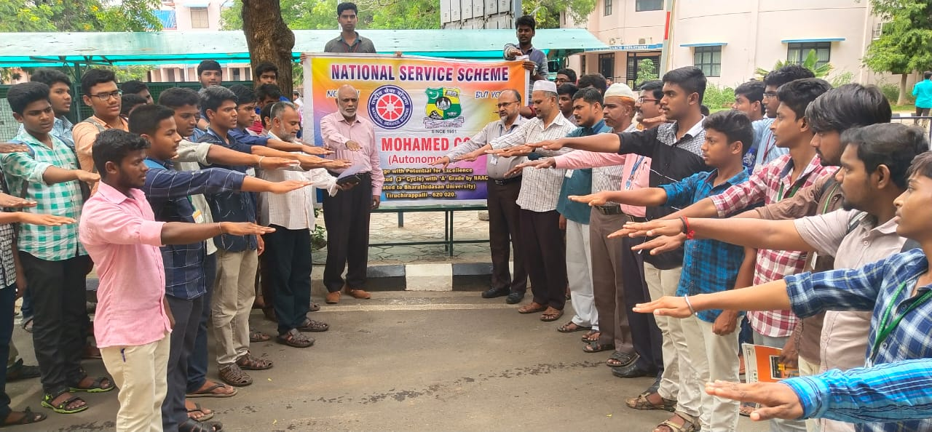
FIT INDIA MOVEMENT @ JMC
On the date of 29/08/2019, FIT INDIA PROGRAMME was celebrated by the NSS VOLENTEER’S in JAMAL MOHAMED COLLEGE at COMPUTER SCIENCE SEMINAR HALL.

NO. OF PARTICIPANT: 150 DATE: 29/08/2019
VENUE: JMC
HOURS : 5hr TIME : 9.30 AM to 02.30PM
CHIEF GUEST:JMC MANAGEMENT
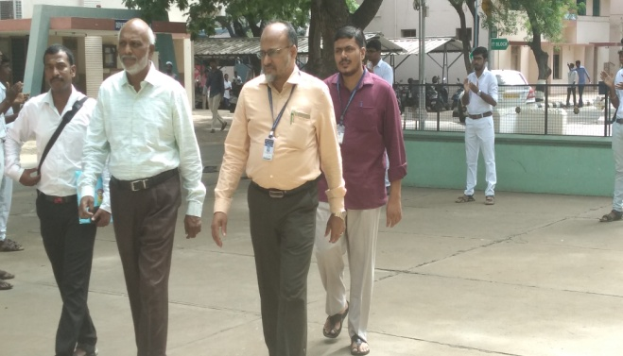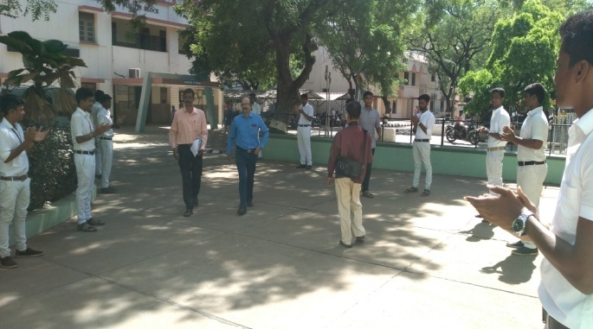
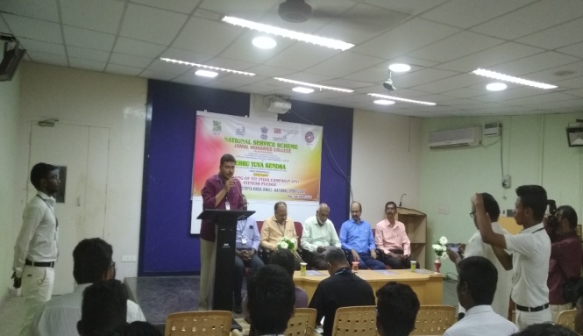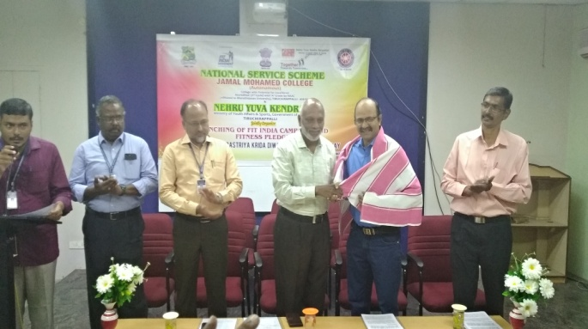

FIT INDIA MOVEMENT @ BDU
On the date of 29/08/2019, FIT INDIA PROGRAMME was celebrated by the NSS VOLUNTEER’S in BDU at Khajamalai.

NO. OF PARTICIPANT : 40 DATE :29/08/2019
VENUE : BDU KHAJAMALAI
HOURS :3hr TIME :10.00 AM to 01.00PM
CHIEF GUEST: Vice chancellor of BDU MANISANKAR
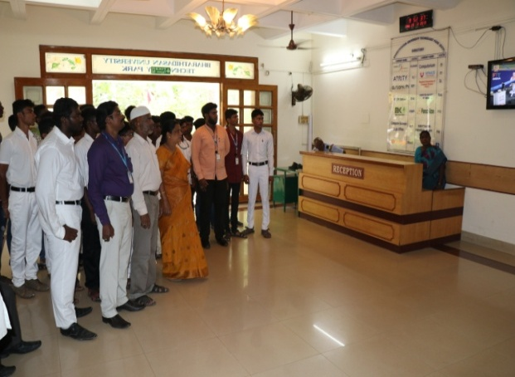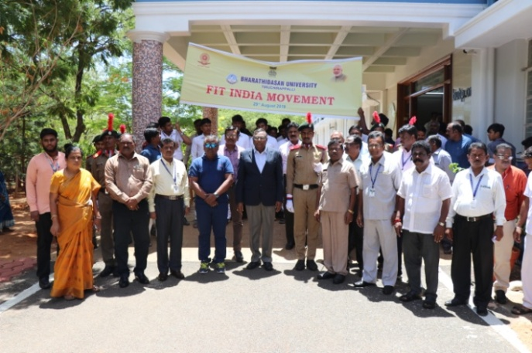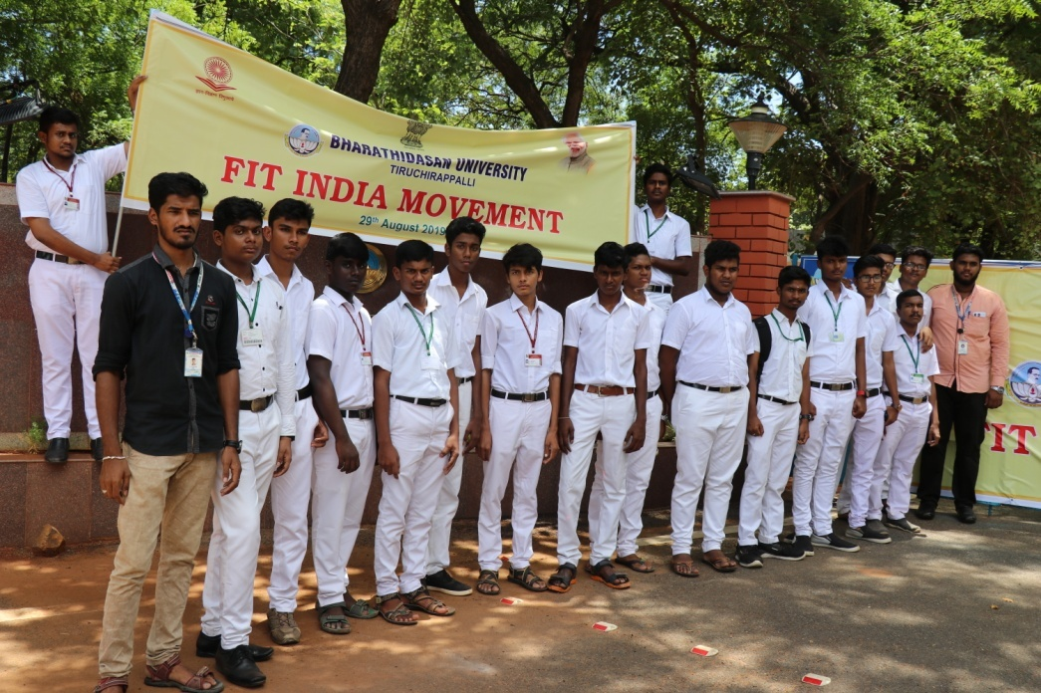
ORIENTATION FUNCTION
On the date of 30/08/2019, ORIENTATION FUNCTION was celebrated by the NSS VOLENTEER’S in hall .

NO. OF PARTICIPANT : 204 DATE :30/08/2019
VENUE : JMC
HOURS :05 hrs TIME : 09:00 AM to 02:00 PM
CHIEF GUEST : BDU NSS CO ORDINATOR Dr. A.LAKSHMI PRABHA
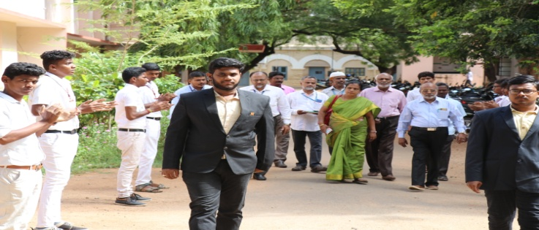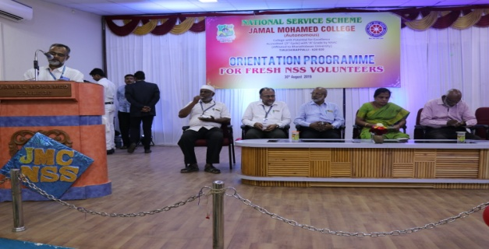
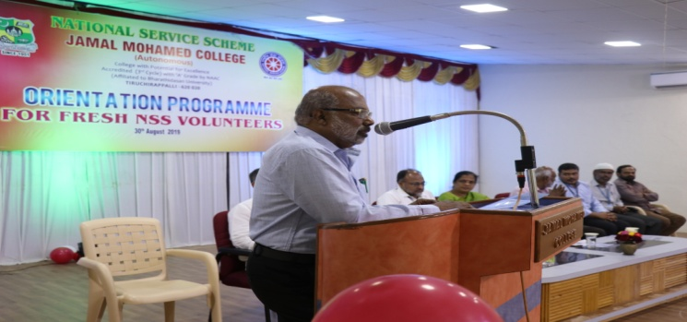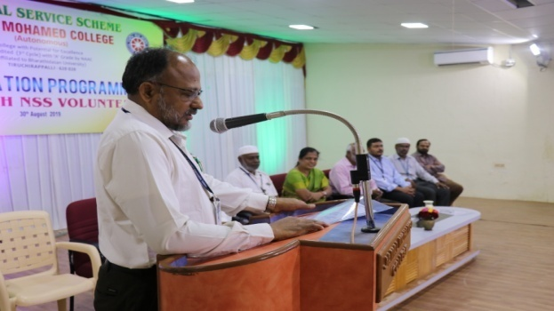
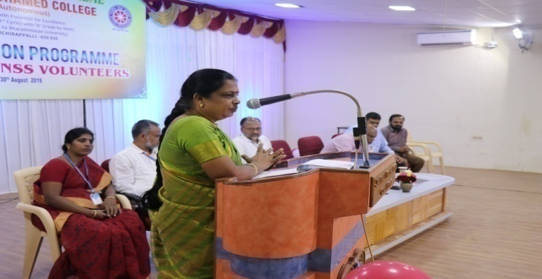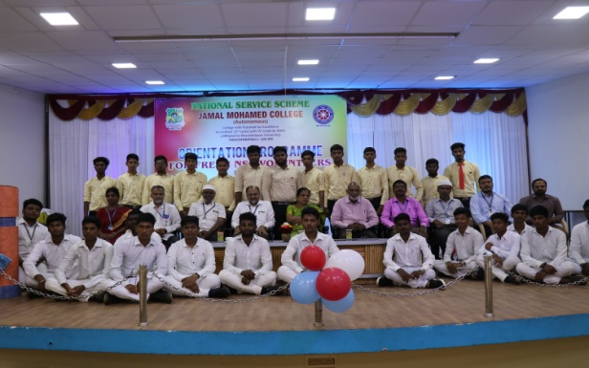

TEACHER’S DAY PROGRAMME
On the date of 05/09/2019, TEACHER’S DAY PROGRAMME was celebrated by the NSS VOLENTEER’S in JMC campus.
The programme was a mass success because of the co-ordinator of volunteers.
NO. OF PARTICIPANT : 30 DATE :05/09/2019
VENUE : JMC campus
HOURS :04 hrs TIME : 07:30 AM to 11:30 AM
CHIEF GUEST : JMC MANAGEMENT
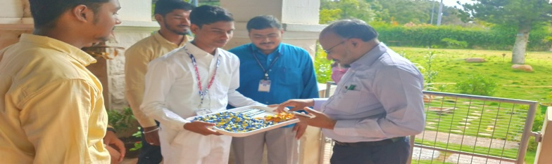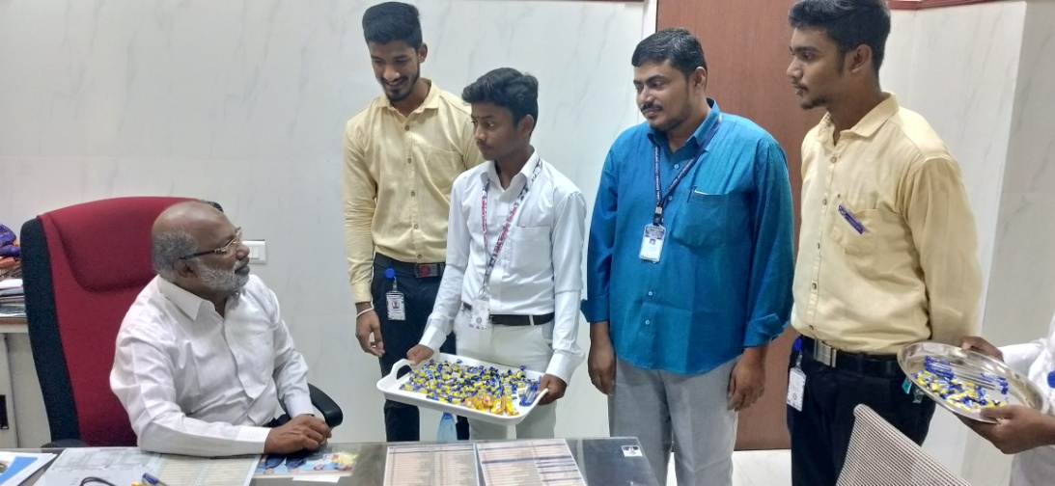
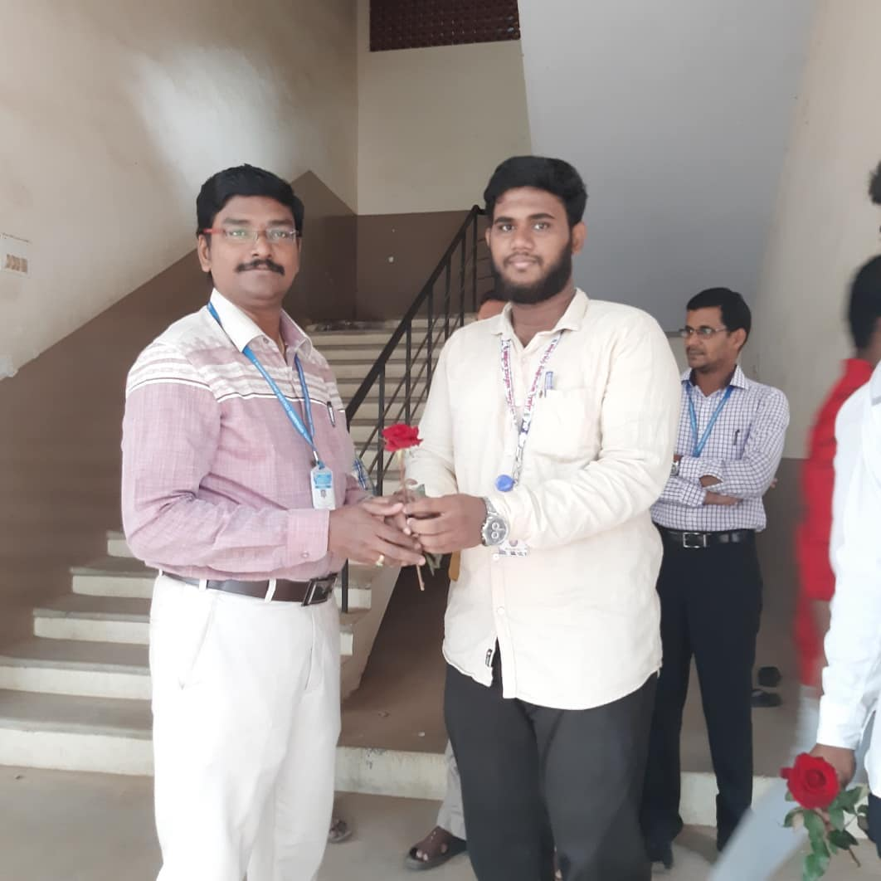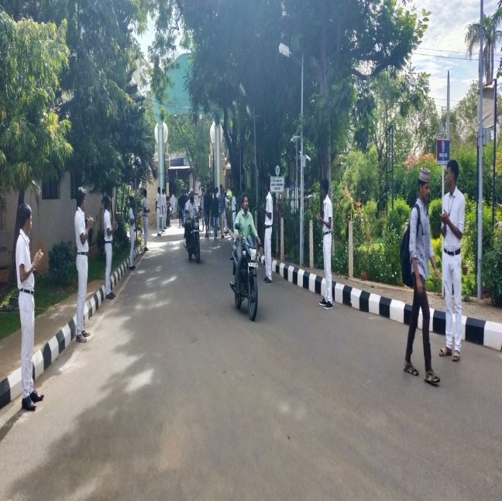

TEACHER’S DAY CLELBRATION
On the date of 03/08/2019, TEACHER’S DAY CLELBRATION was celebrated by the NSS cell of Bharathidasan University and Joseph’s Eye Hospital.
The programme was a mass success because of the co-ordinator of volunteers.
NO. OF PARTICIPANT : 07 DATE : 05/08/2019
VENUE : JMC MANGEMENT
HOURS :4 hr TIME : 09:30AM to 10:30 AM
CHIEF GUEST: Dr.A.LAKSHMI PRABA
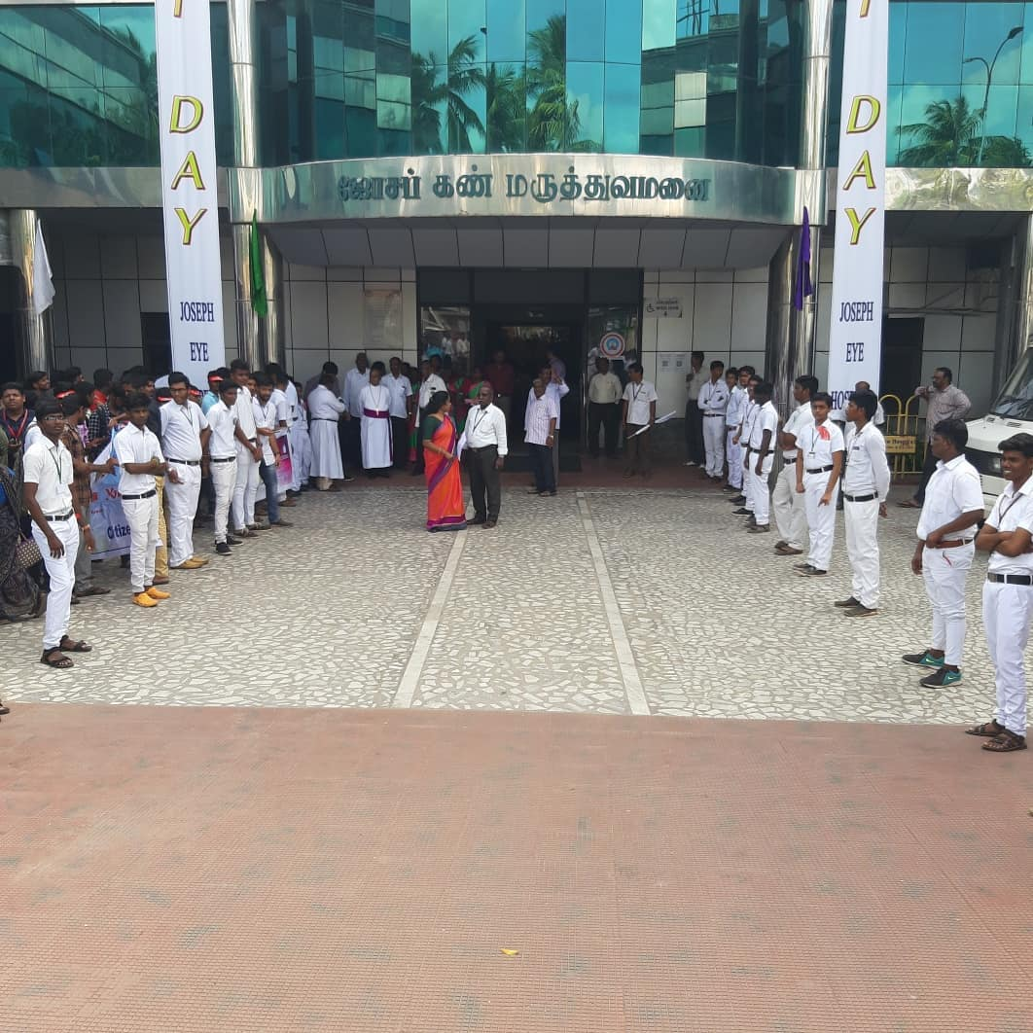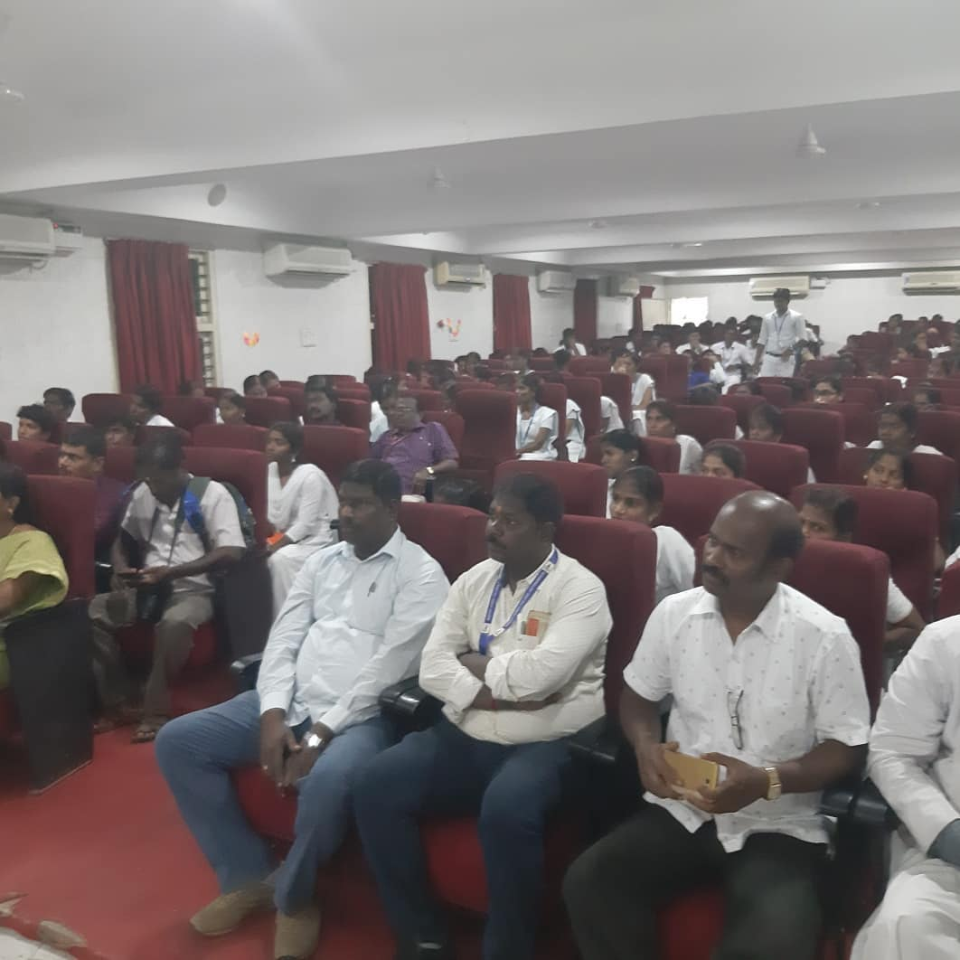
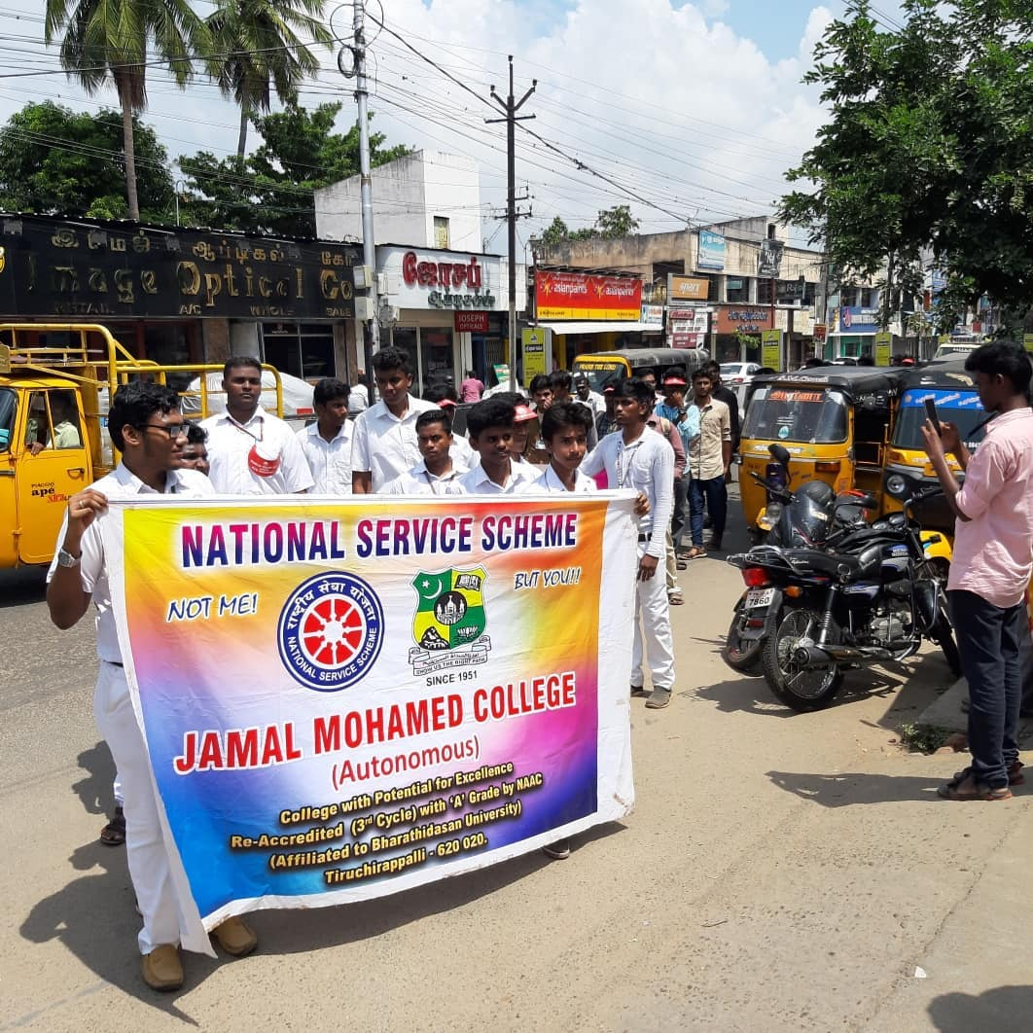

RESEARCH WORKSHOP
On the date of 06/09/2019,RESERCH WORKSHOP was conducted by the NSS VOLENTEER’S in JMC.
The programme was a mass success because of the co-ordinator of volunteers.
NO. OF PARTICIPANT : 06 DATE :06/09/2019
VENUE : JMC
HOURS :05.00 hrs TIME : 08:30 AM to 12:30 PM CHIEF GUEST:
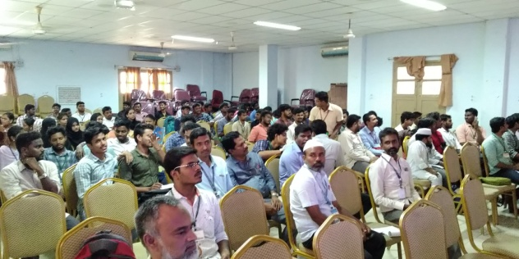
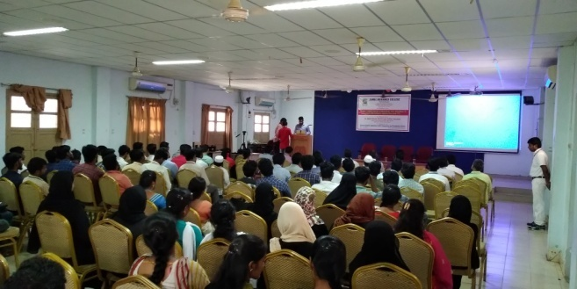
KOVIL KUMBABISAGAM
On the date of 12/09/19, KOVIL KUMBABISAGAM was participated by the NSS VOLENTEER’S in Ponaumpalayam.
The programme was a mass success because of the co-ordinator of volunteers.
NO. OF PARTICIPANT : 65 DATE :12/09/2019
VENUE : Ponaumpalaiyam
HOURS :06 hr TIME : 08:00 AM to 02:00 PM
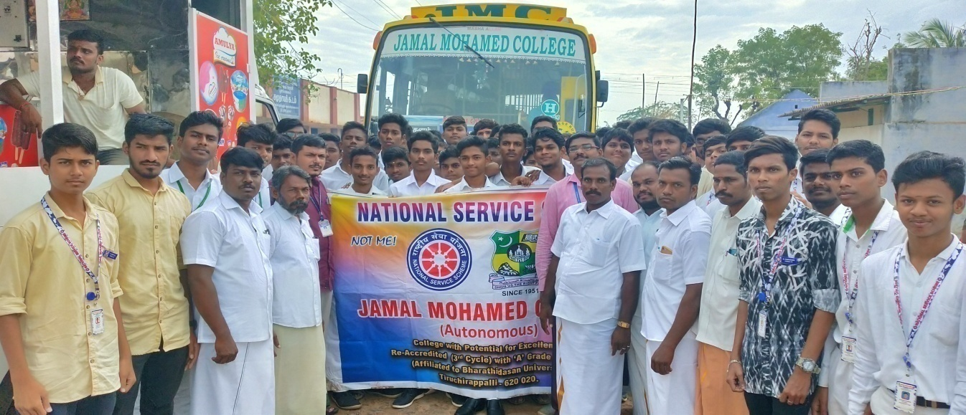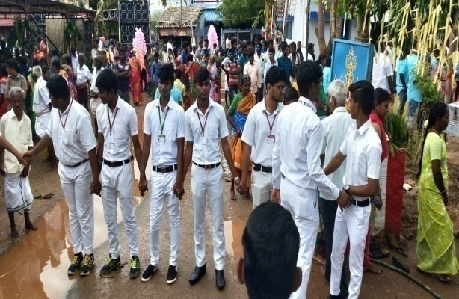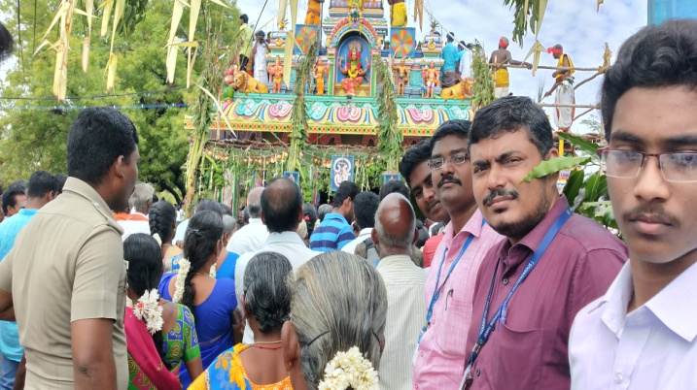

BLOOD DONATION
On the date of 13.09.2019, Our NSS Voluteers are donate 01 UNIT of blood in SRM HOSPITAL,TRICHY.
NO. OF PARTICIPANT : 02 DATE :12/09/2019
VENUE : SRM
HOURS :03 hrs TIME : 08:00 AM to 11:00 AM
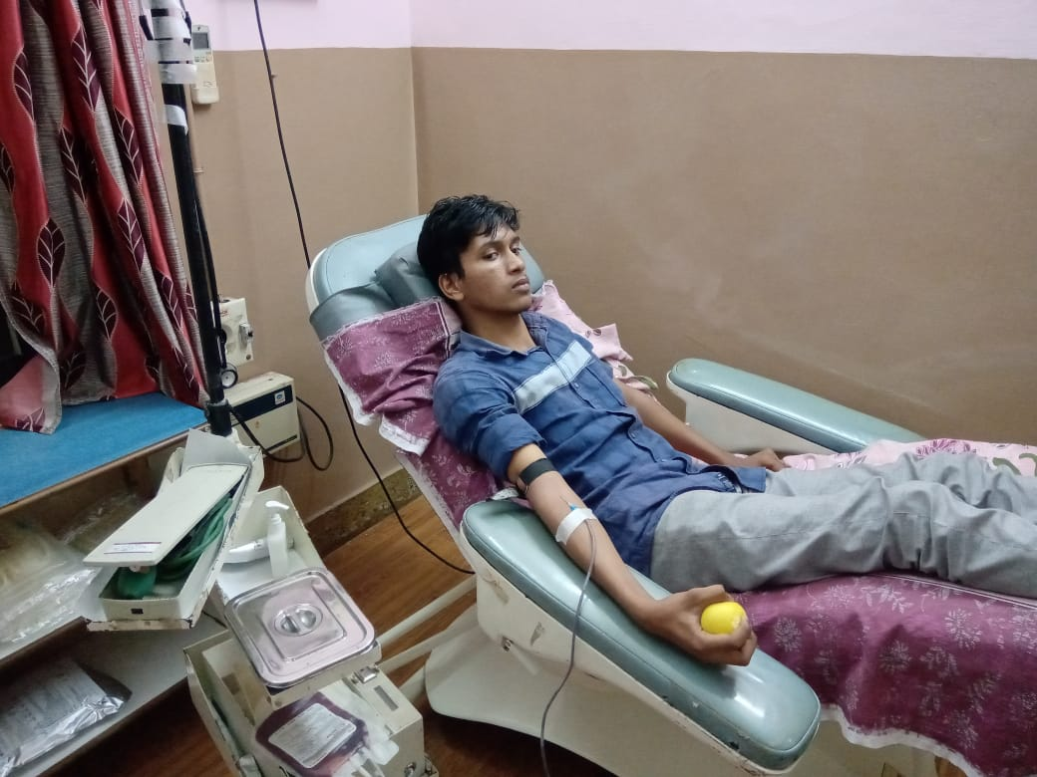
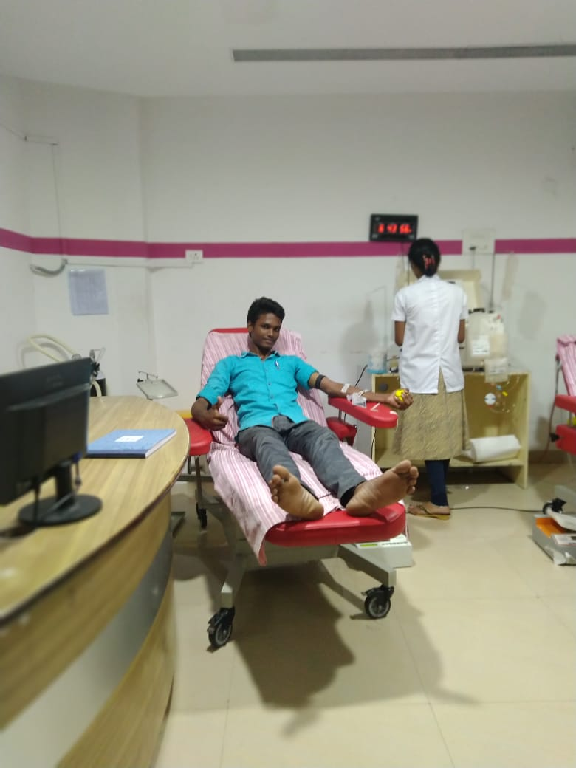

PERIYAR BIRTH DAY CELEBRATION AT BDU
On the date of 17/09/2018, PERIYAR AND ANNA BIRTHDAY FUNCTION was participated by the NSS VOLENTEER’S in Bharathidasan University , Trichy.
The programme was a mass success because of the co-ordination of volunteers.
NO. OF PARTICIPANT : 25 DATE :17/09/2019
VENUE : BDU
HOURS :06 hr TIME : 08:30 AM to 02:30 PM CHIEF GUEST: Vice chancellor of BDU MANISANKAR
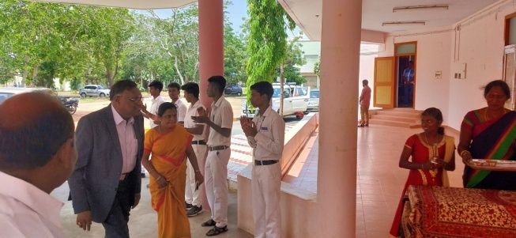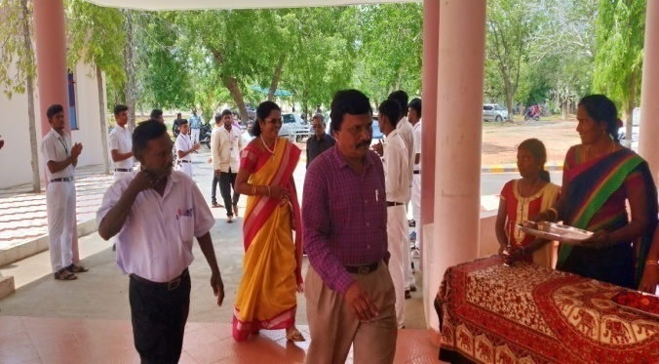
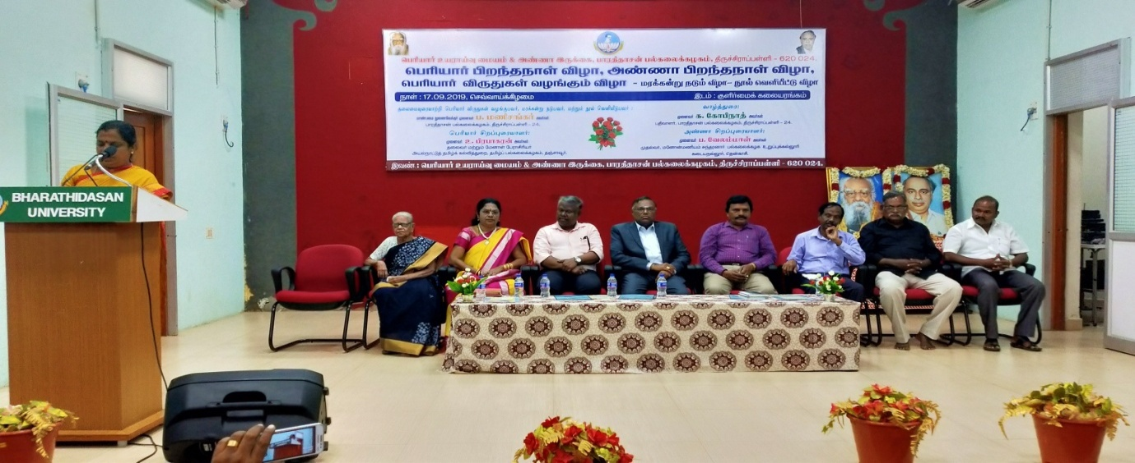

NUTRITION-POSHAU MAAH
On the date of 18/09/2019, NUTRITION POSHAU MAAH PROGRAMME was celebrated by the NSS VOLENTEER’S in JAMAL MOHAMED COLLEGE at CHEMISTRY SEMINAR HALL.
The programme was a mass success because of the co-ordination of volunteers.
NO. OF PARTICIPANT : 100 DATE :18/09/2019
VENUE : JMC
HOURS :03 hr TIME : 10:30 AM to 01:30 PM CHIEF GUEST: YASMIN FATHIMA
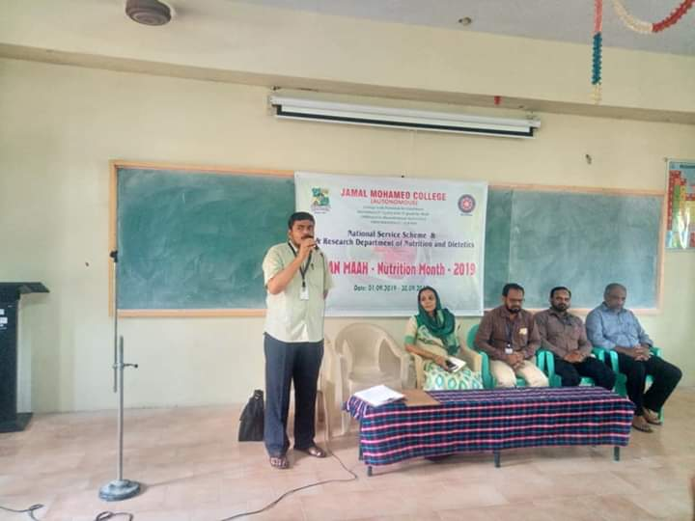
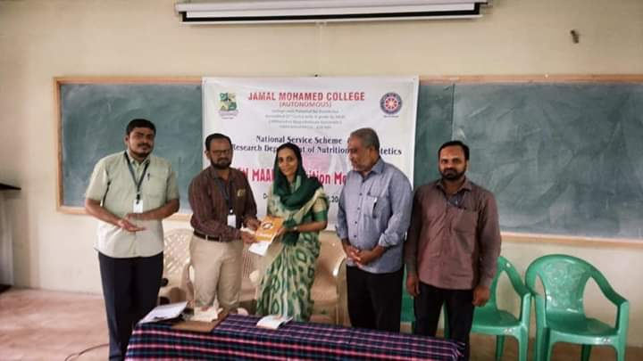
NUTRITION-POSHAU MAAH
On the date of 19/09/2019, NUTRITION POSHAU MAAH PROGRAMME was conducted by the NSS VOLENTEER’S in Economics Seminar Hall.
The programme was a mass success because of the co-ordination of volunteers.
NO. OF PARTICIPANT : 110 DATE :19/09/2019
VENUE : JMC
HOURS :03 hr TIME : 11:30 AM to 02:30 PM CHIEF GUEST: Dr.M.ANGEL
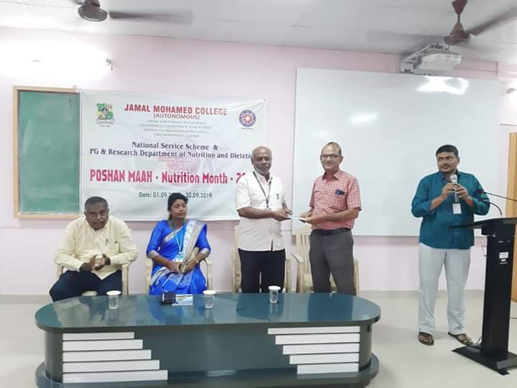
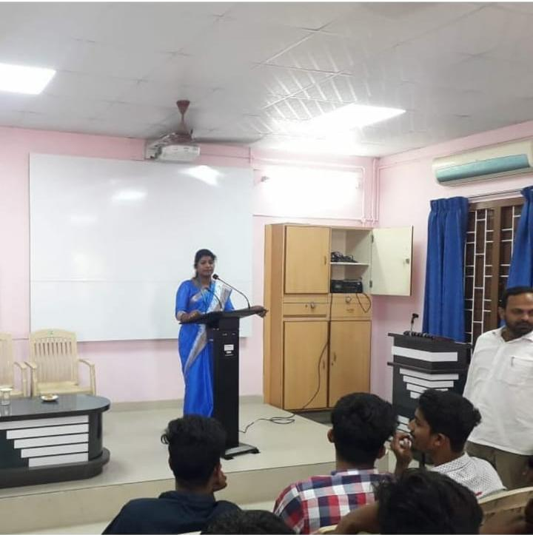
NUTRITION-POSHAU MAAH
On the date of 23/09/2019, NUTRITION POSHAU MAAH PROGRAMME was celebrated by the NSS VOLENTEER’S in JAMAL MOHAMED COLLEGE at CHEMISTRY SEMINAR HALL.
The programme was a mass success because of the co-ordination of volunteers.
NO. OF PARTICIPANT : 10 DATE :23/09/2019
VENUE : JMC
HOURS :02hr TIME : 11:30 AM to 01:30 PM
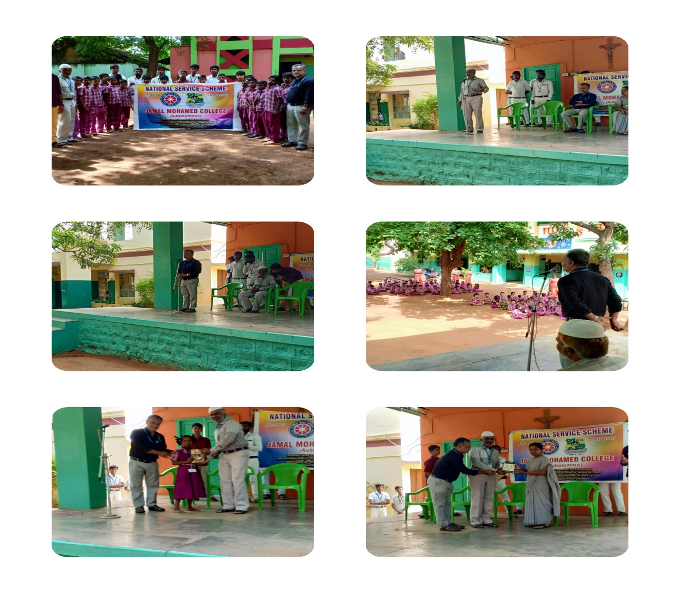
TRAFFIC AWARNESS PROGRAMME AT COLLECTOR’S OFFICE
On the date of 23/09/2019,TRAFFIC AWARNESS PROGRAMME was conducted by the COLLECTOR’S OFFICE atr the CHILDREN’S TRAFFIC PRAK,TRICHY

NO. OF PARTICIPANT : 25 DATE :23/09/2019
VENUE : JMC
HOURS :03hr TIME : 11:30 AM to 02:30 PM
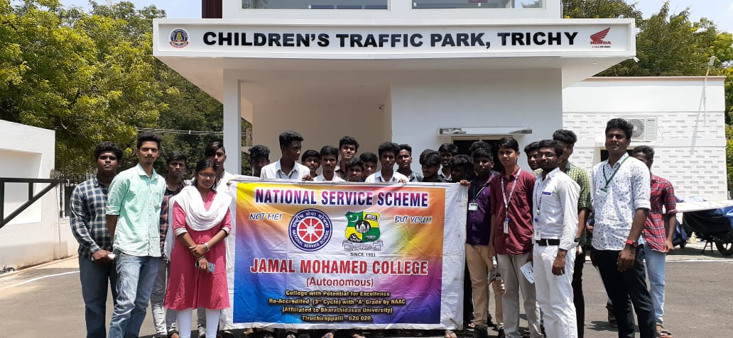

NSS DAY
On the date of 24/09/2018, NSS DAY PROGRAMME was conducted by the NSS VOLENTEER’S in KHAJAMIAN AUDITORIUM.
The programme was a mass success because of the co-ordinator of volunteers.
NO. OF PARTICIPANT : 200 DATE :24/09/2019
VENUE : JMC
HOURS :05 hr TIME : 09:00 AM to 02:00 PM CHIEF GUEST: Dr.S.KAMARAJ
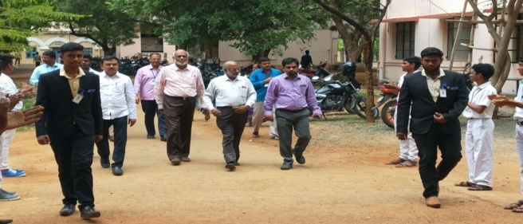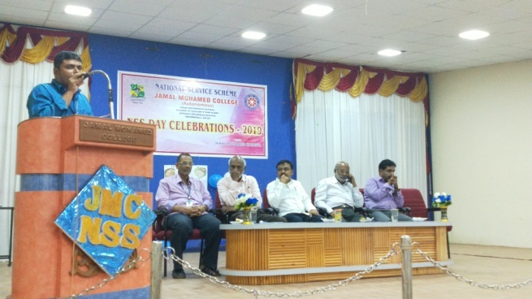
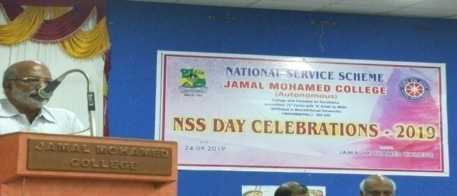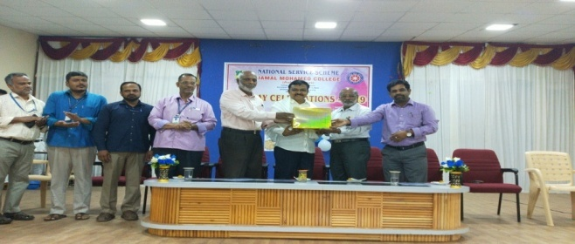
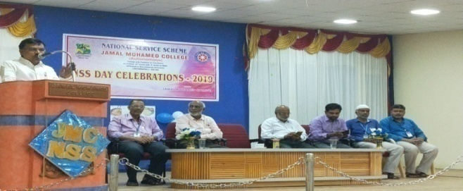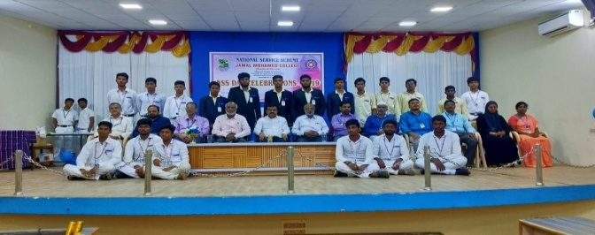
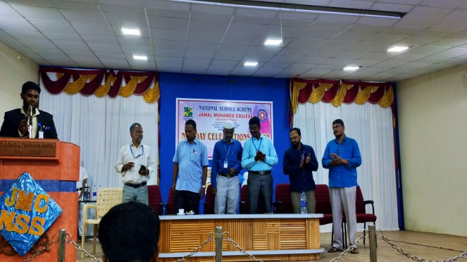
ONE DAY WORKSHOP @ St.JOSEPH’S COLLEGE
On the date of 24/09/2018, ONE DAY WORKSHOP ON SOCIAL LEADERSSHIP AND PERSONAITY SKILLS NSS Unit of St.Joseph’s college at St.Joseph’s college campus.
The programme was a mass success because of the co-ordinator of volunteers.
NO. OF PARTICIPANT : 10 DATE :24/09/2019
VENUE : St.Joseph’s college
HOURS :8.00 hrs TIME : 09:00 AM to 05:00 PM CHIEF GUEST:
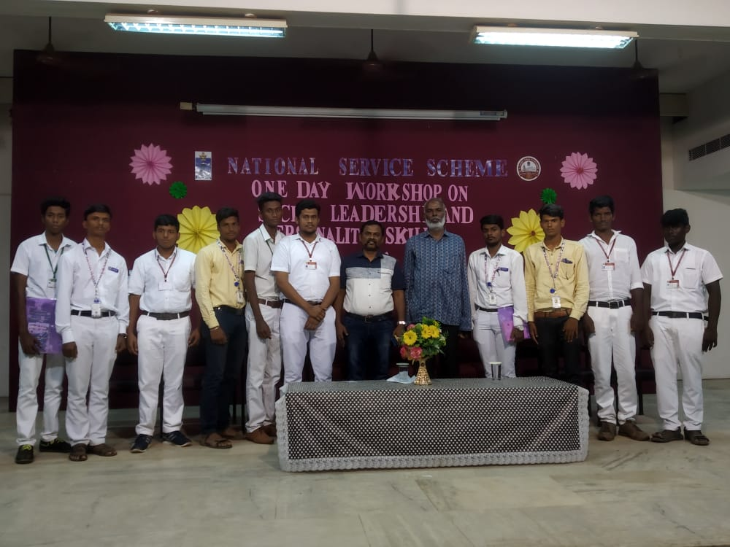
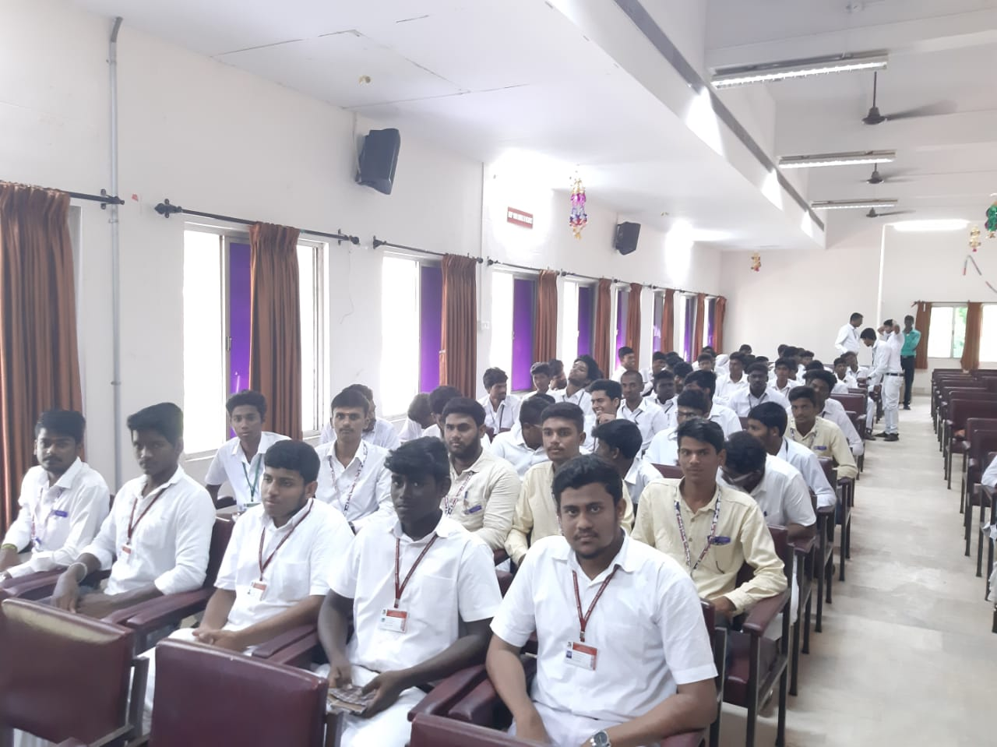
TREE PLANTATION PROGRAME
On the date of 25.09.19 TREE PLANTATION PROGRAME was conduct by village social workers and JMC NSS and EXNORA of Jamal Mohamed College at Gunder.
NO. OF PARTICIPANT :15` DATE:25/09/2019
VENUE :GUNDUR
HOURS :5 hr TIME : 09:00 AM to 2:00 PM CHIEF GUEST: MAYIL VAGANAM IPS

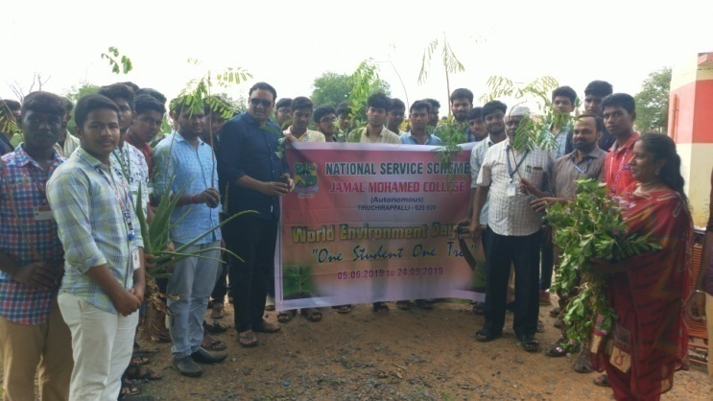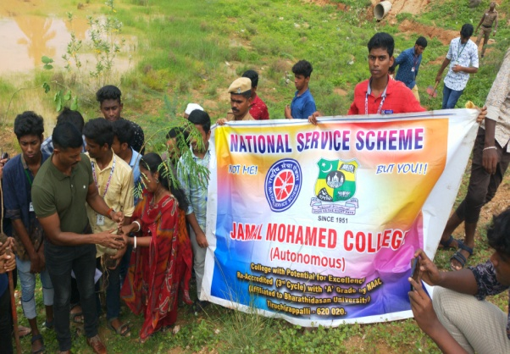

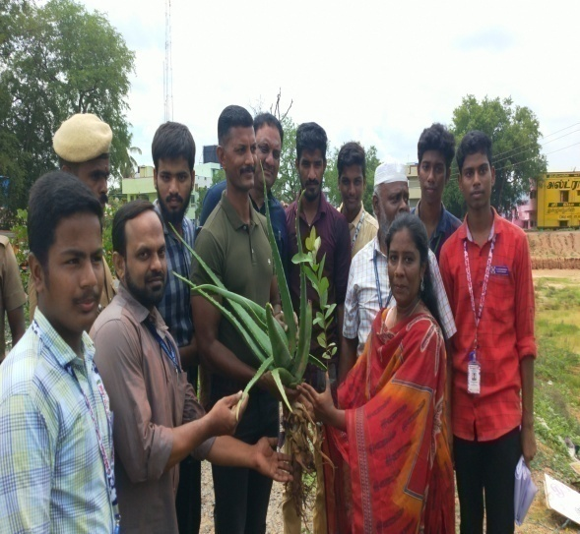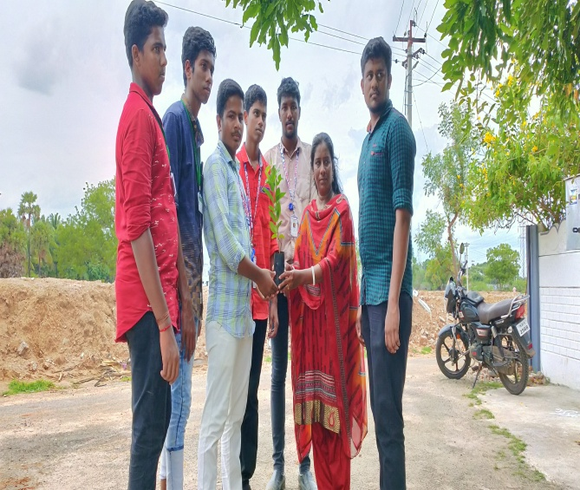

PRIVATE JOB FAIR CAMP
On the date of 28/09/2019, PRIVATE JOB FAIR PROGRAMME was conducted by the GOVERNMENT OF TAMILNADU DISTRICT ADMINISTRATION AND DISTRICT EMPLOYMENT OFFICE TIRUCHIRAPPALLI at JAMAL MOHAMED COLLEGE .

NO. OF PARTICIPANT :20 DATE :28/09/2019
VENUE : MINNA BLOCK
HOURS :6 hr TIME : 08:30 AM to 2:30PM
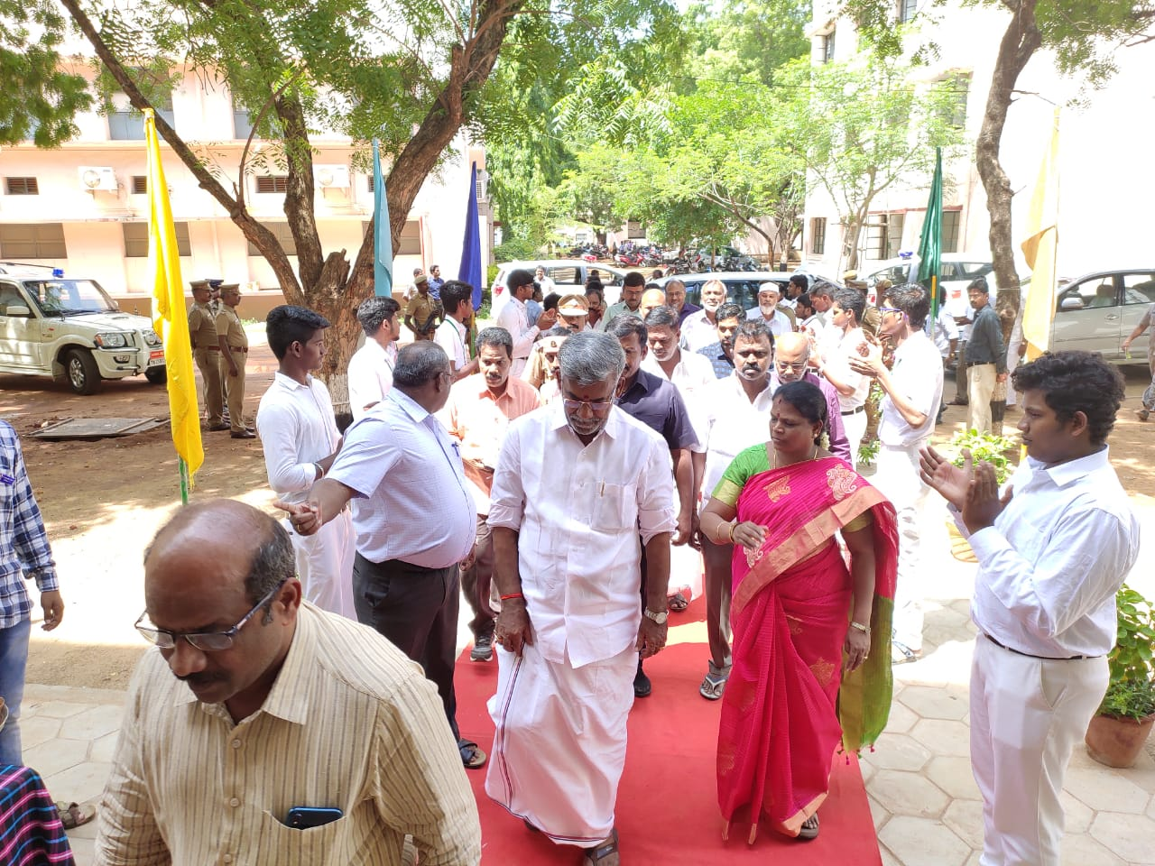
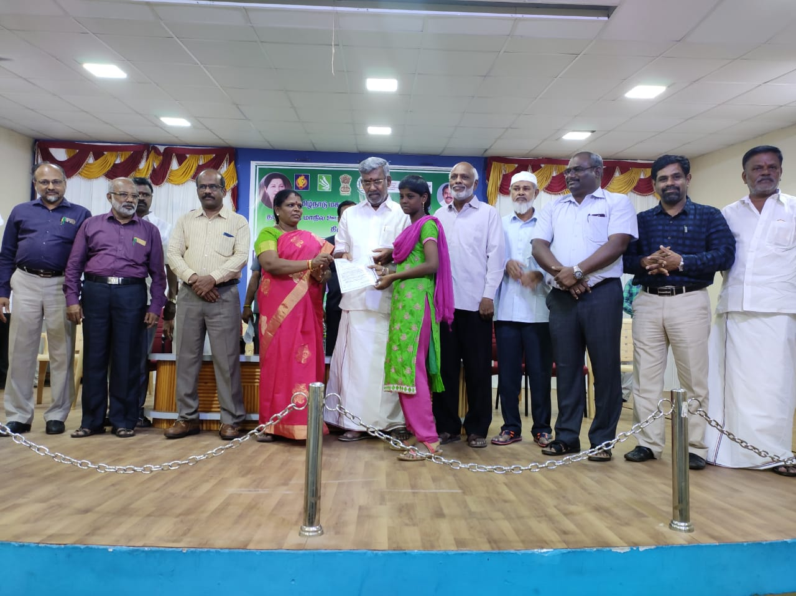
HELMET AWARNESS RALLY
On the date of 29/09/2018. TWO WHEELER HELMET AWARENESS RALLY was conducted by St.JOSEPH EYE HOSPITAL and TIRUCHIRAPPALLI ROTRACT CLUB from old collector office to Ulavar Sandhai.
NO. OF PARTICIPANT : 25 DATE:29/09/2019
VENUE : ULAVER SANDHAI
HOURS :03 hr TIME : 7:30 AM to 10:30 PM

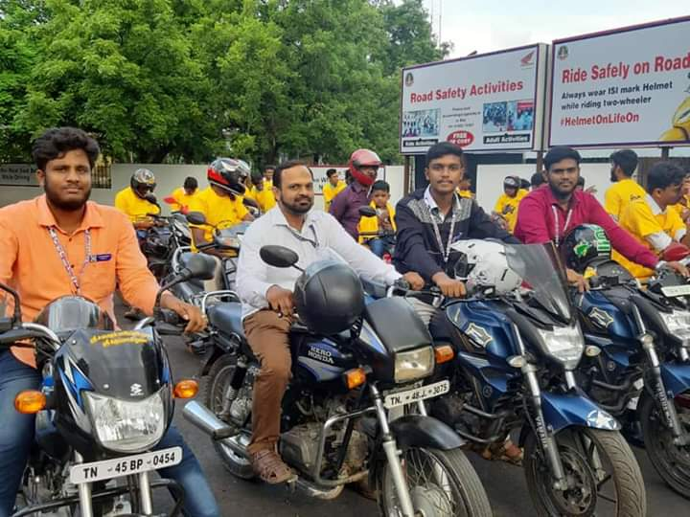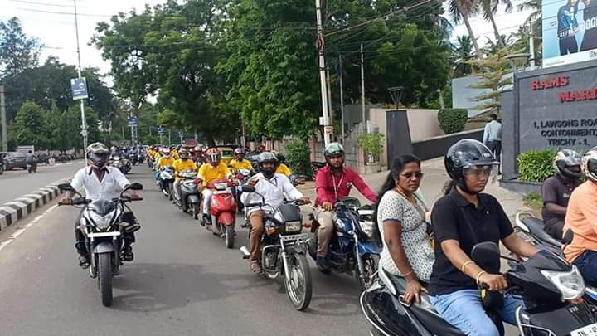
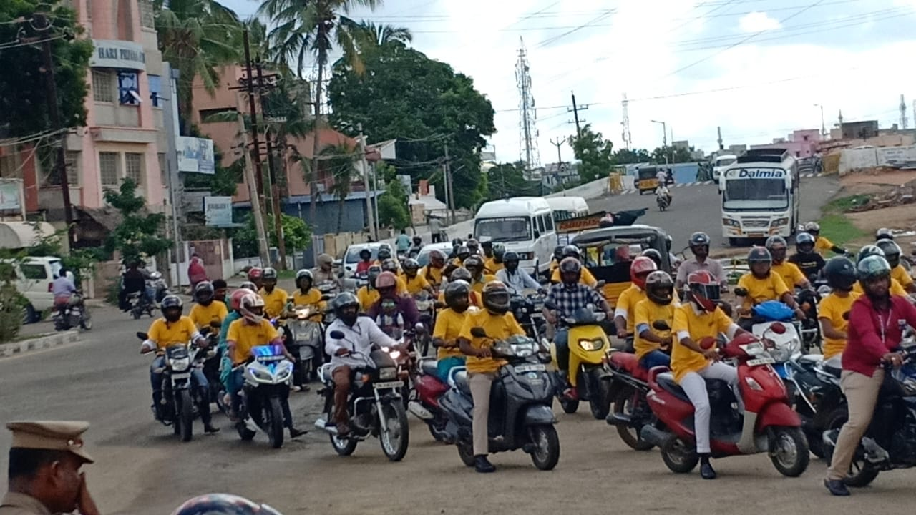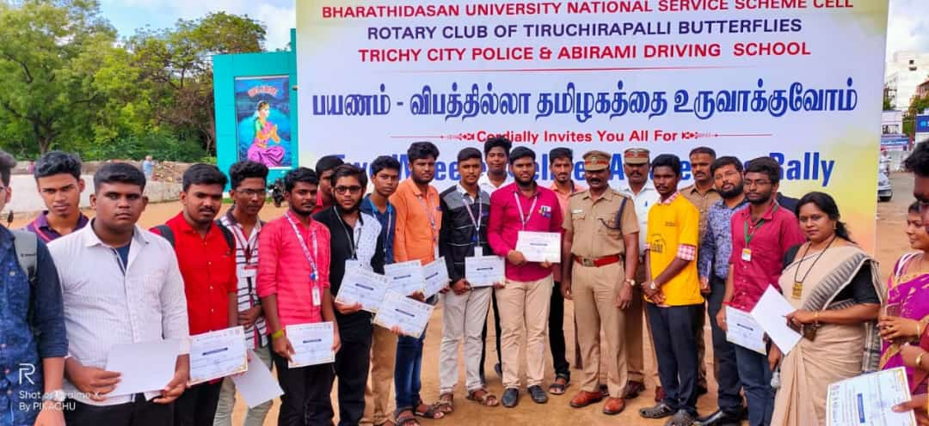

BHARATHIDASAN UNIVERSITY CONVOCATION
On the date of 01/10/2019, BHARATHIDASAN UNIVERSITY CONVOCATION was conduct by the BHARATHIDASAN UNIVERSITY TRICHY.
The programme was a mass success because of the co-ordinator of volunteers.
NO. OF PARTICIPANT : 70 DATE : 01/10/2019
VENUE : JMC MANGEMENT
HOURS : 5 hr TIME : 01:30PM to 06:30 PM
CHIEF GUEST: HONOURABLE TAMILNADU GOVERNER BANWARILALBUROHIT
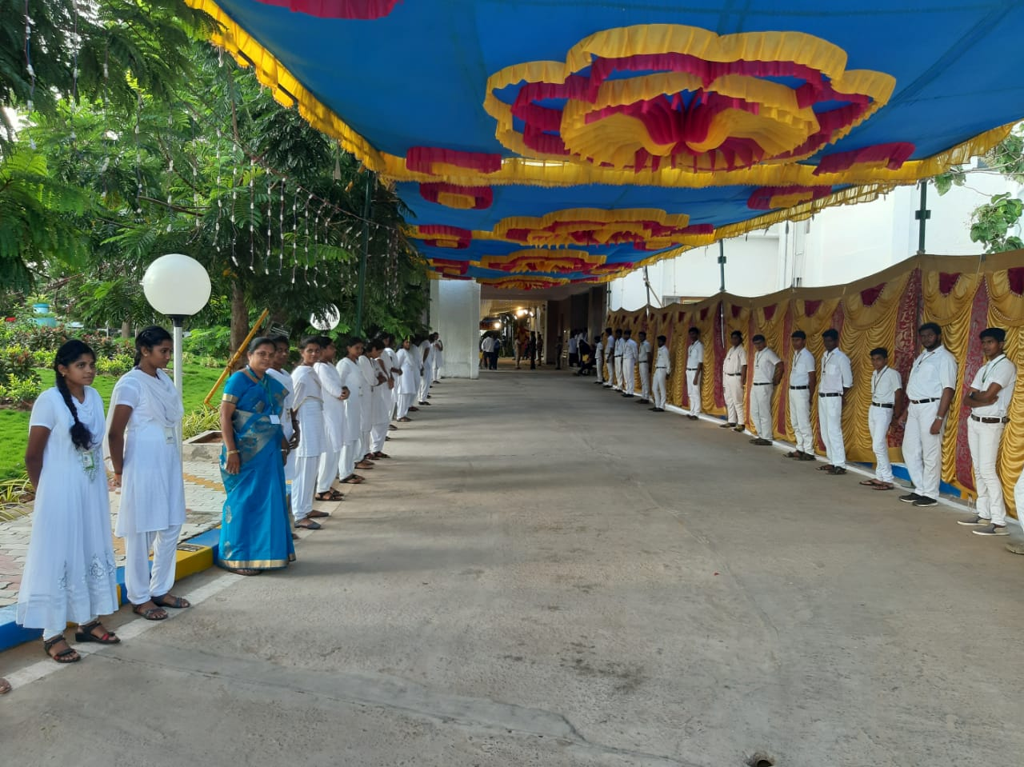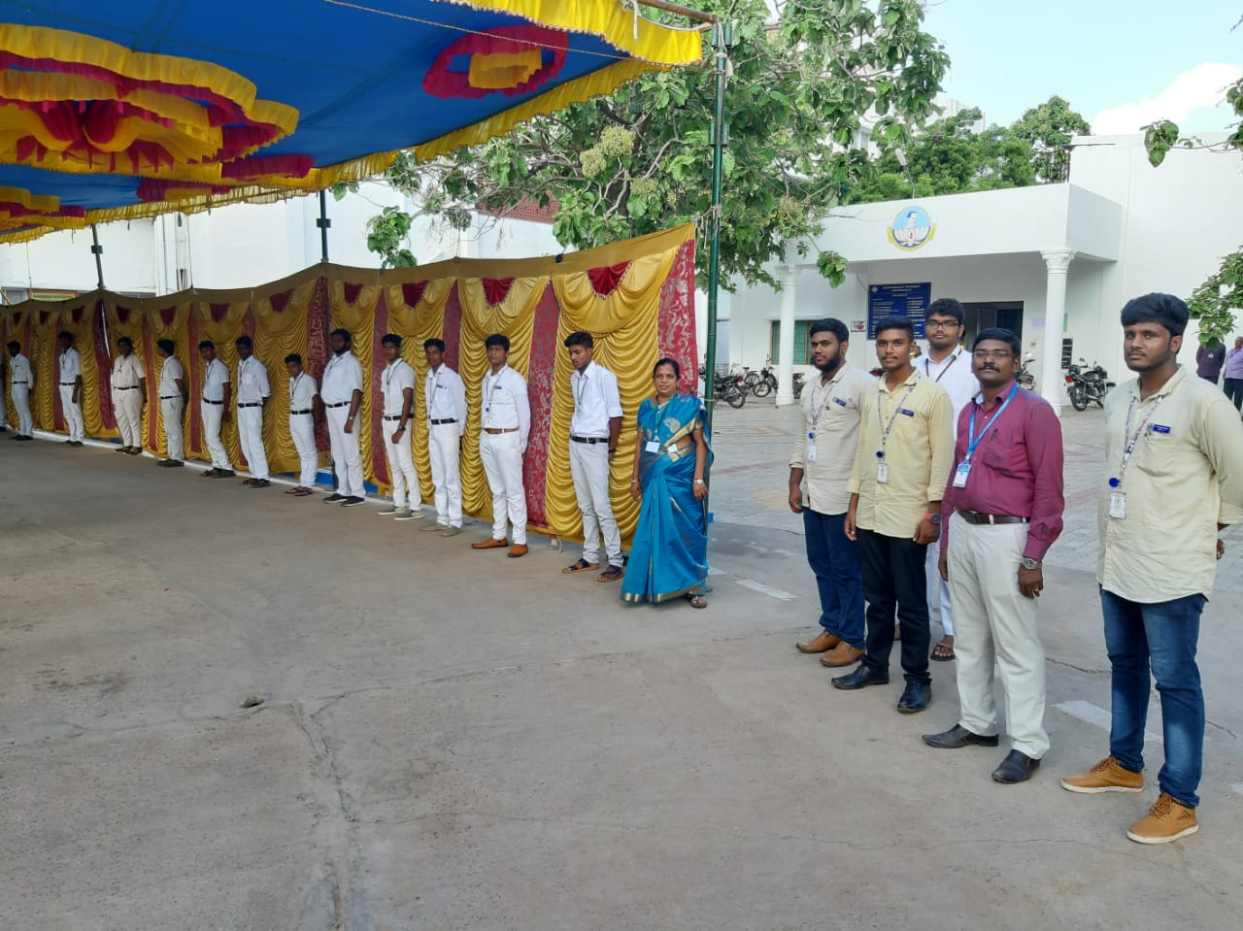
WORLD SIGHT DAY
On the date of 10/10/2019, WORLD SIGHT DAY was conduct by the NSS cell of Bharathidasan University and Joseph’s Eye Hospital.
The programme was a mass success because of the co-ordinator of volunteers.
NO. OF PARTICIPANT : 25 DATE : 10/10/2019
VENUE : JOSEPH EYE HOSPITAL
HOURS :3 hr TIME : 09:30AM to 12:30 PM
CHIEF GUEST: Dr.A.LAKSHMI PRABA AND Dr. MANISANKAR,VC
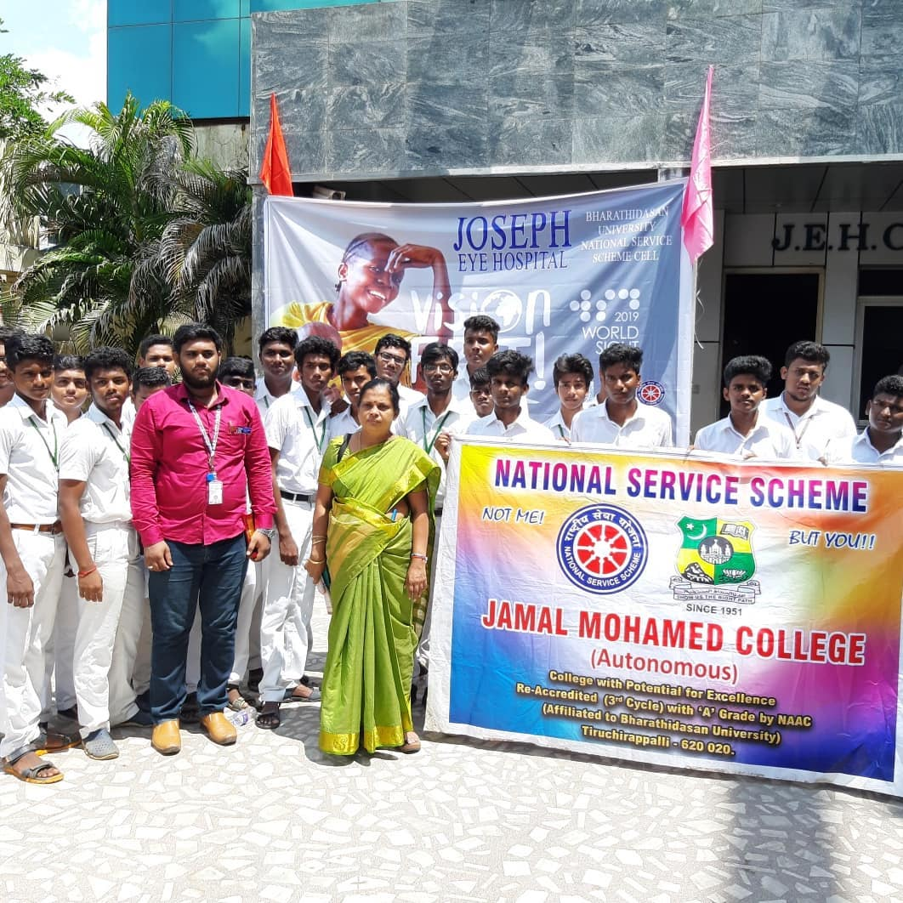
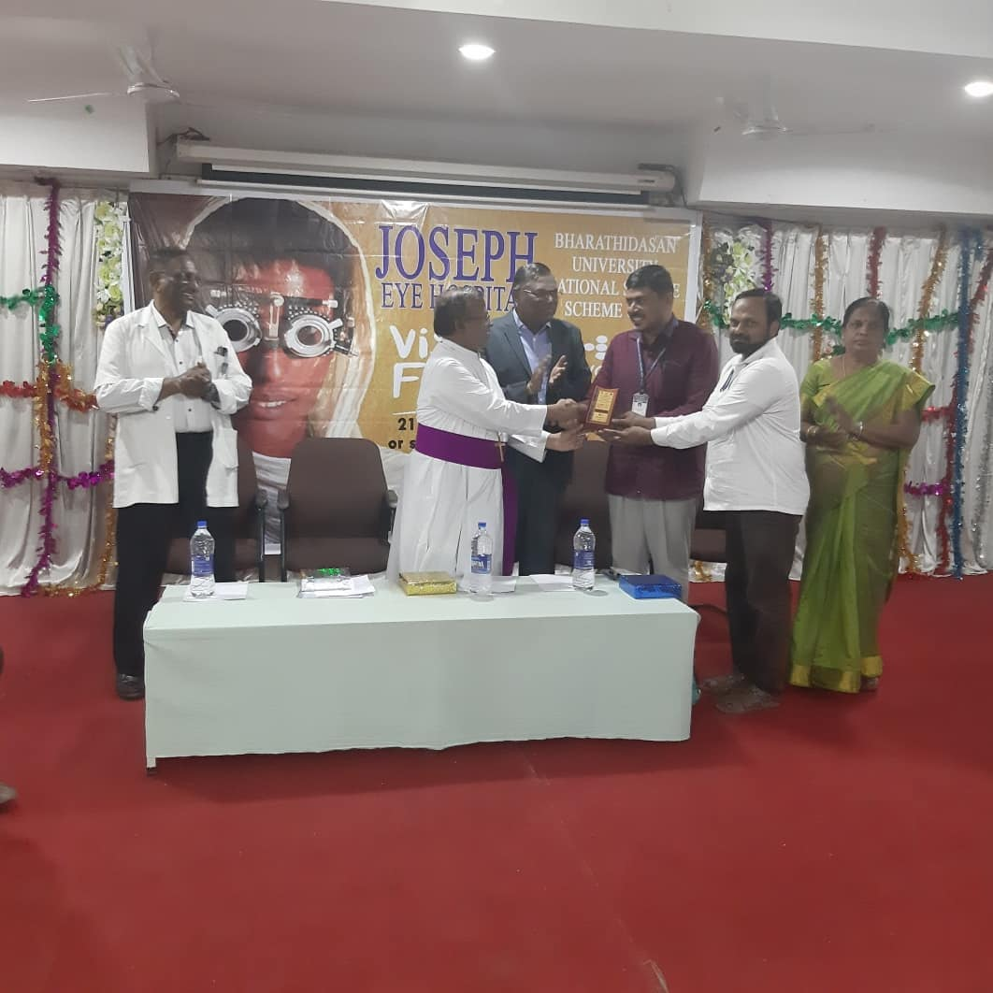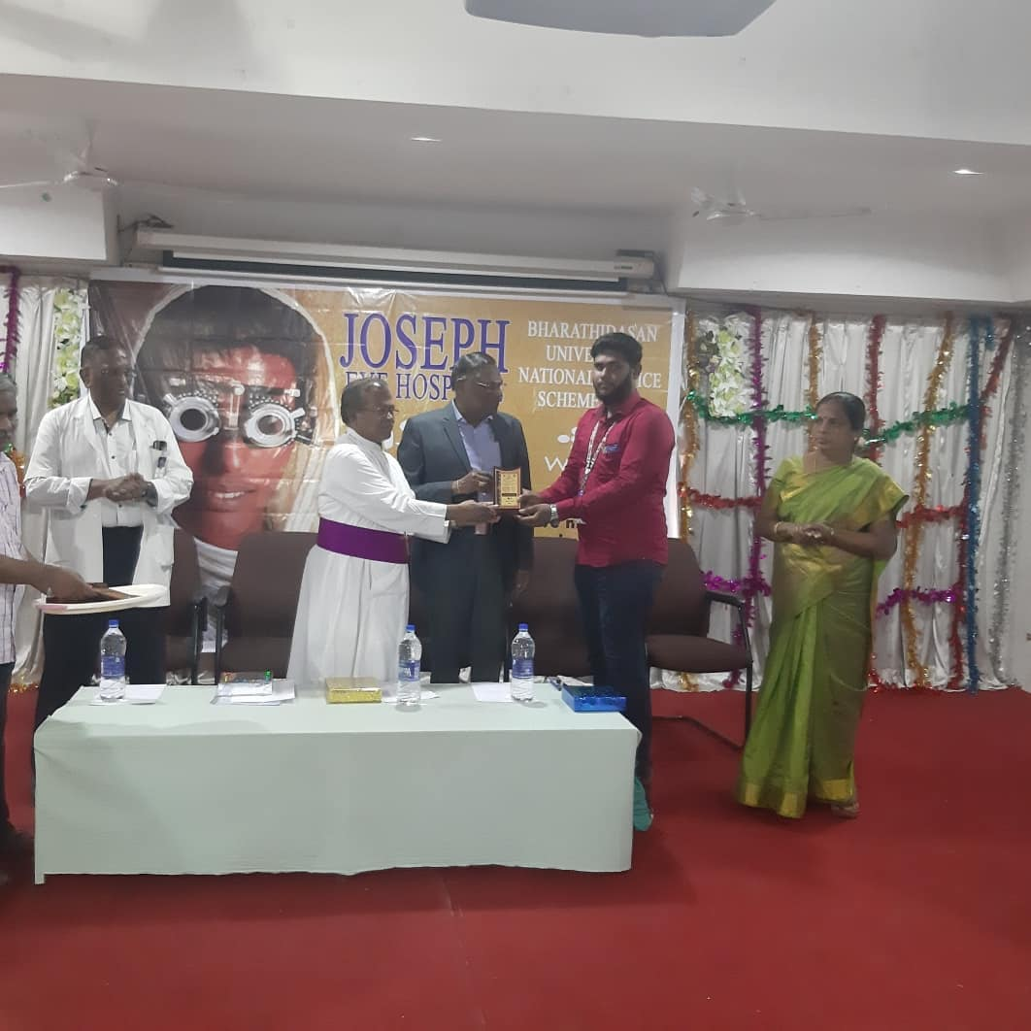

MAHATHMA GANDHI BIRTHDAY CELEBRATION
On the date of 11/10/2019, MAHATHMA GANDHI BIRTHDAY CELEBRATION FUNCTION was participated by the NSS VOLENTEER’S in Bharathidasan University , Trichy.
The programme was a mass success because of the co-ordinator of volunteers.
NO. OF PARTICIPANT : 12 DATE :11/10/2019
VENUE : BDU
HOURS :08 hr TIME : 08:30 AM to 04:30 PM
CHIEF GUEST: Dr.A.LAKSHMI PRABA
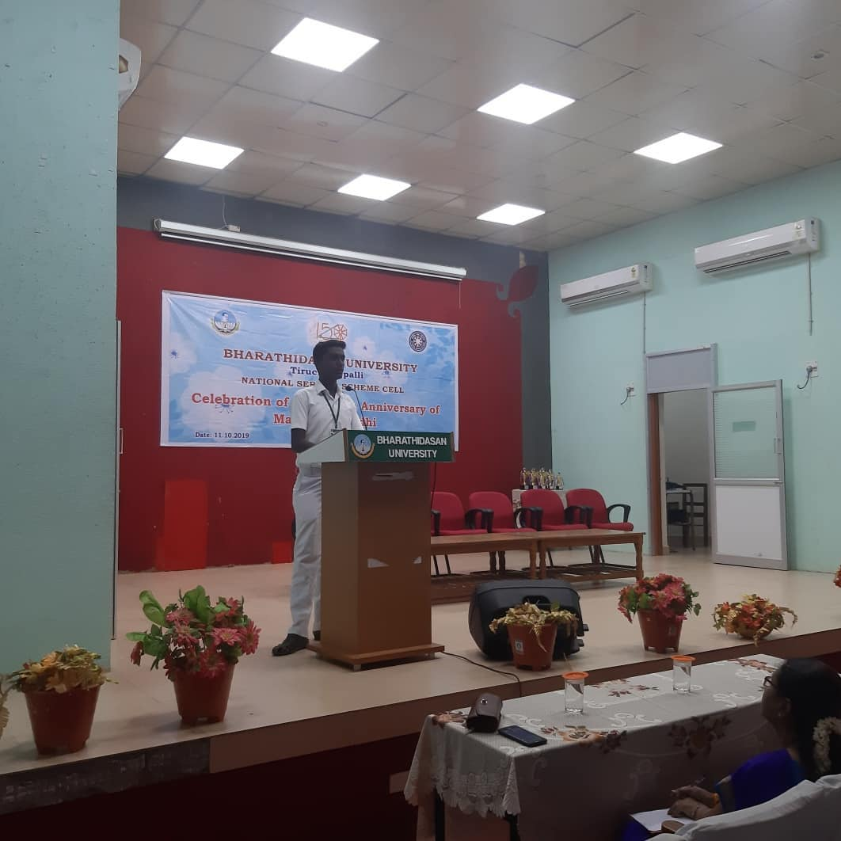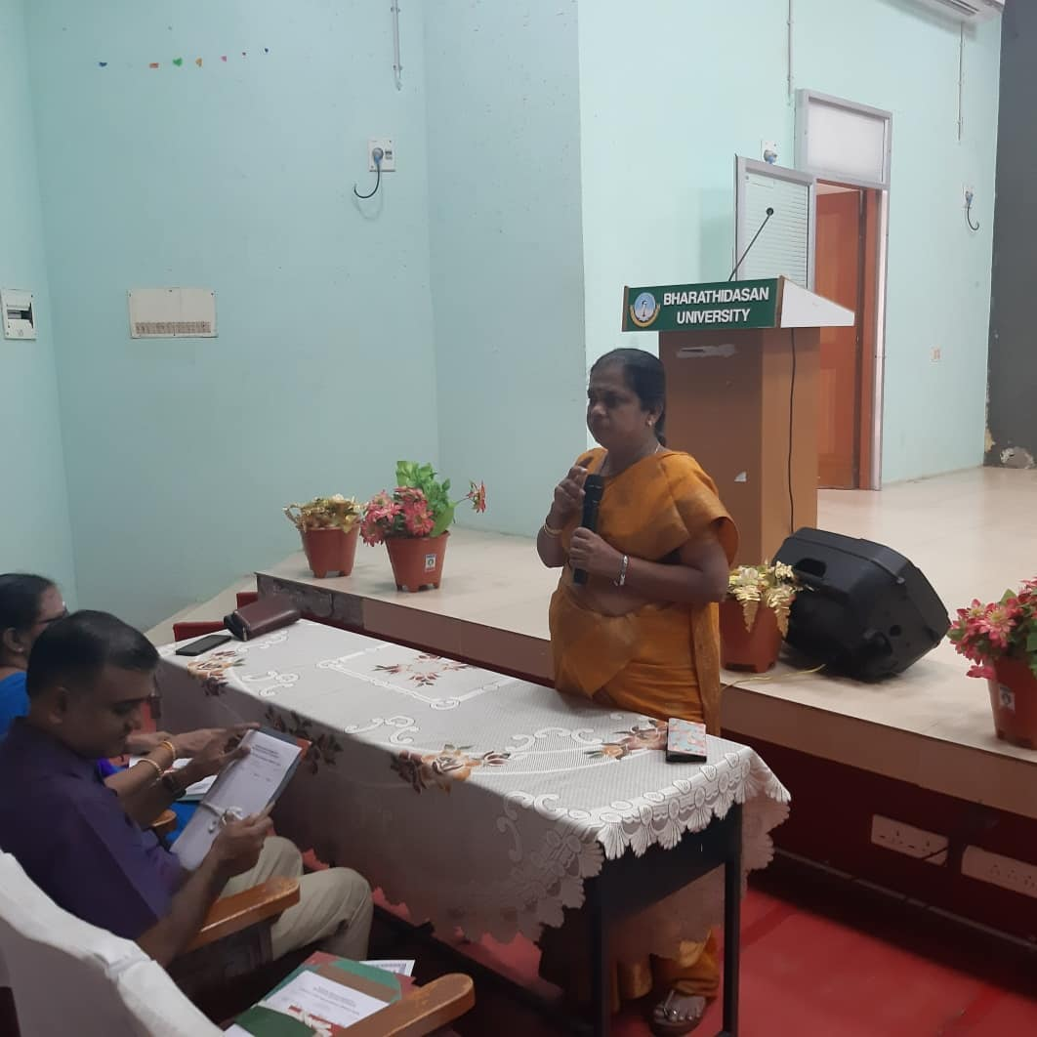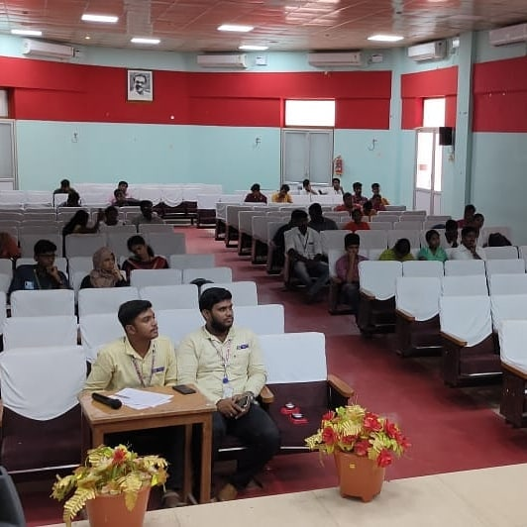
NATIONAL YOUTH AWAKENING DAY
On the date of 15/10/2019, NATIONAL YOUTH AWAKENING DAY was conduct by the NSS wing of Jamal Mohamed college at our college campous.
The programme was a mass success because of the co-ordinator of volunteers.
NO. OF PARTICIPANT : 80 DATE : 15/10/2019
VENUE : JMC MANGEMENT
HOURS :2 hr TIME : 09:30AM to 11:30 AM
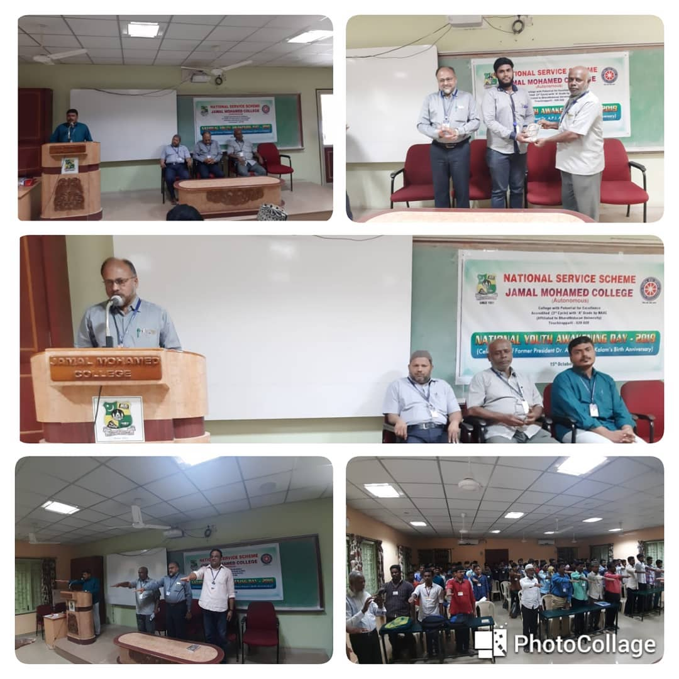
BDU FEST 2019
On the date of 18,19,20/10/2019, BDU FEST – 2018 was conducted by the NSS VOLENTEER’S in BDU.
The programme was a mass success because of the co-ordinator of volunteers.
NO. OF PARTICIPANT : 70 DATE :18/10/2019 – 20/10/2019
VENUE : BDU
TIME : 07:00 AM to 10:00 PM
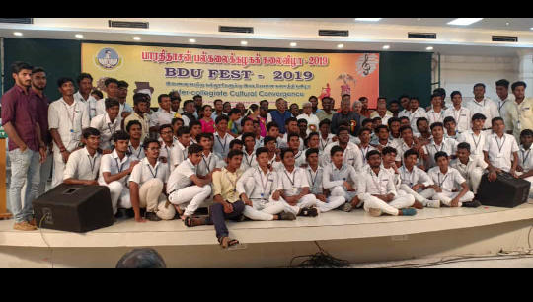

SOUTH ZONE PRE-RD SELECTION CAMP
On the date of 16.10.2019 to 25.10.2019, Our NSS Volunteer M.MOHAMED ARIF was attended in SOUTH ZONE PRE-RD SELECTION CAMP was conducted by MINISTRY OF YOUTH AFFAIRS AND SPORTS GOVERNMENT OF INDIA at National College Trichy.
NO. OF PARTICIPANT : 01
DATE : 16/10/2019 to 25/10/2019
VENUE : National College Trichy
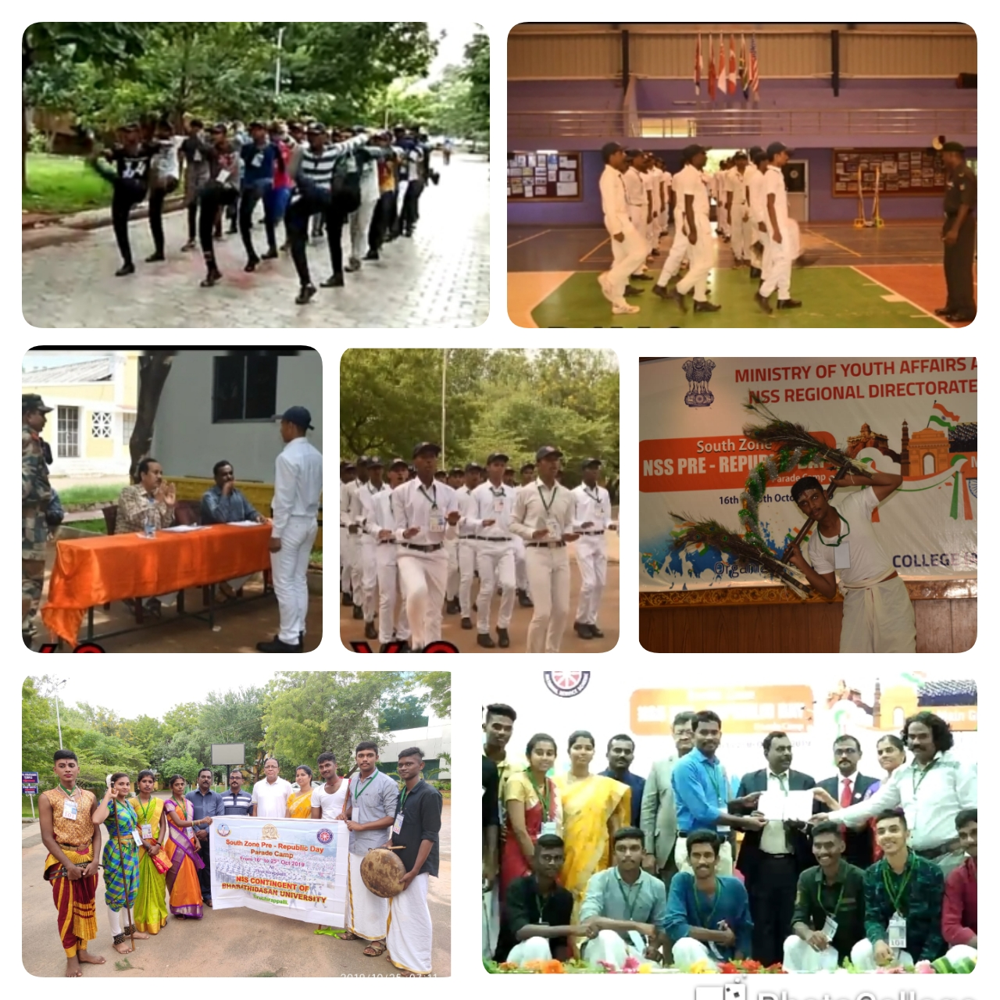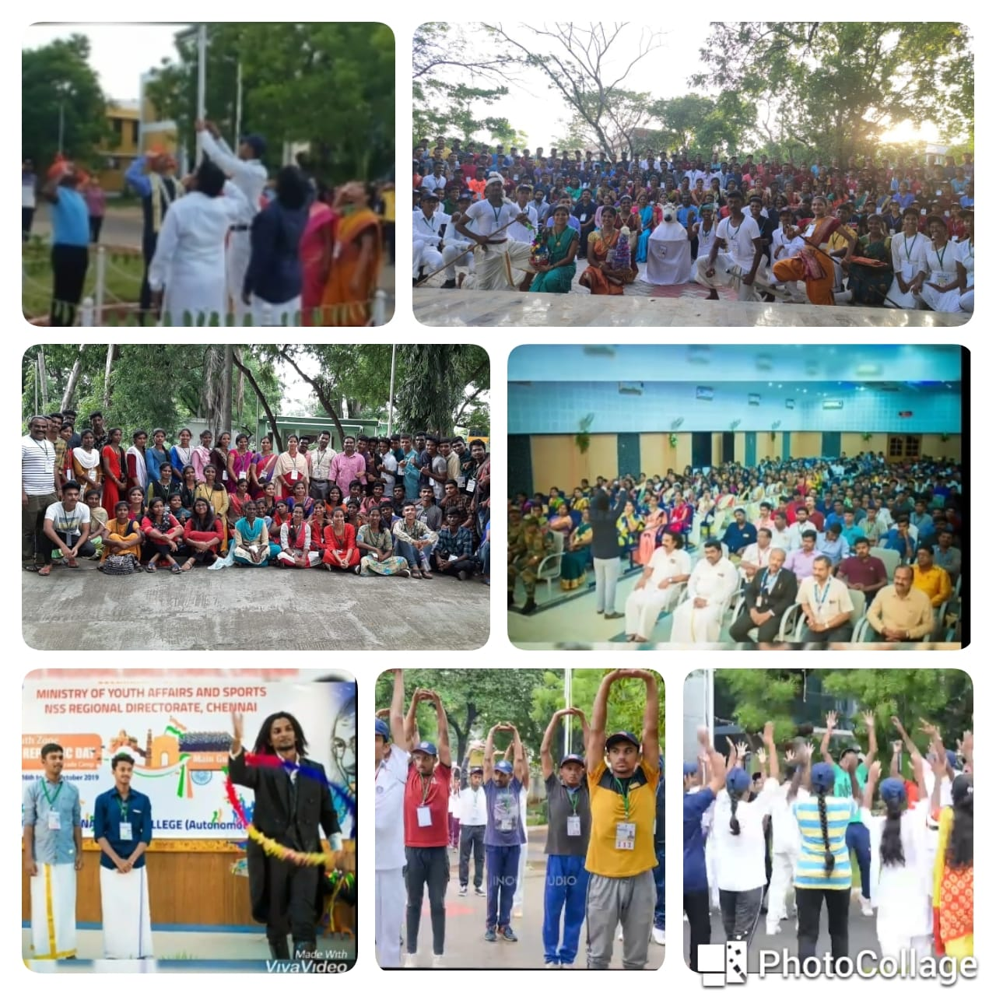
NATIONAL UNITY DAY
On the date of 31/10/2019, NATIONAL UNITY DAY was conduct by the NSS wing of Jamal Mohamed college at our college campous.
The programme was a mass success because of the co-ordinator of volunteers.
NO. OF PARTICIPANT : 100 DATE : 31/10/2019
VENUE : JMC MANGEMENT
HOURS :1 hr TIME : 09:30AM to 10:30 AM
CHIEF GUEST: Dr.A.LAKSHMI PRABA
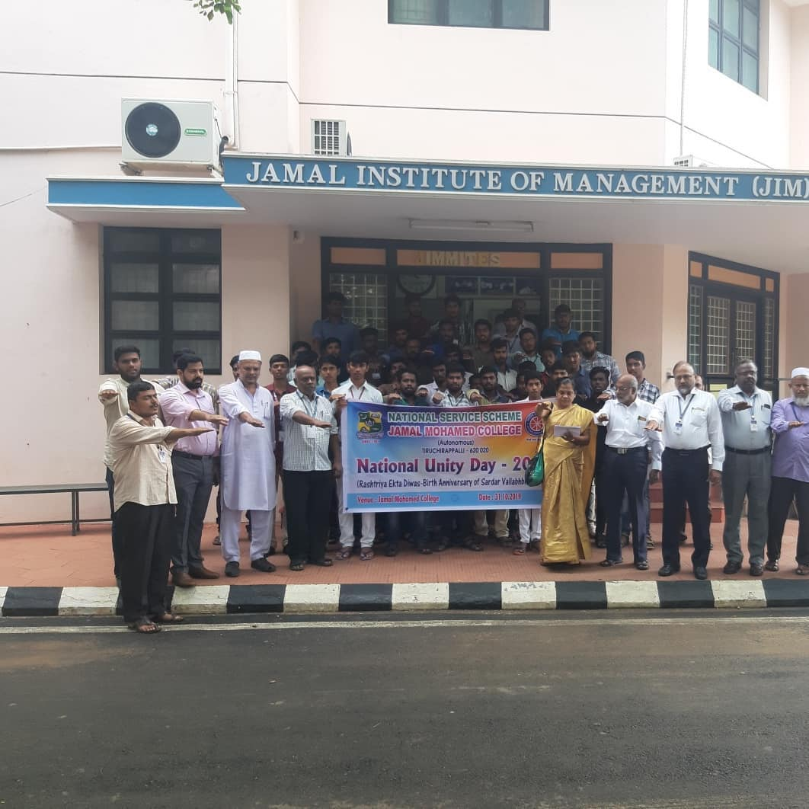
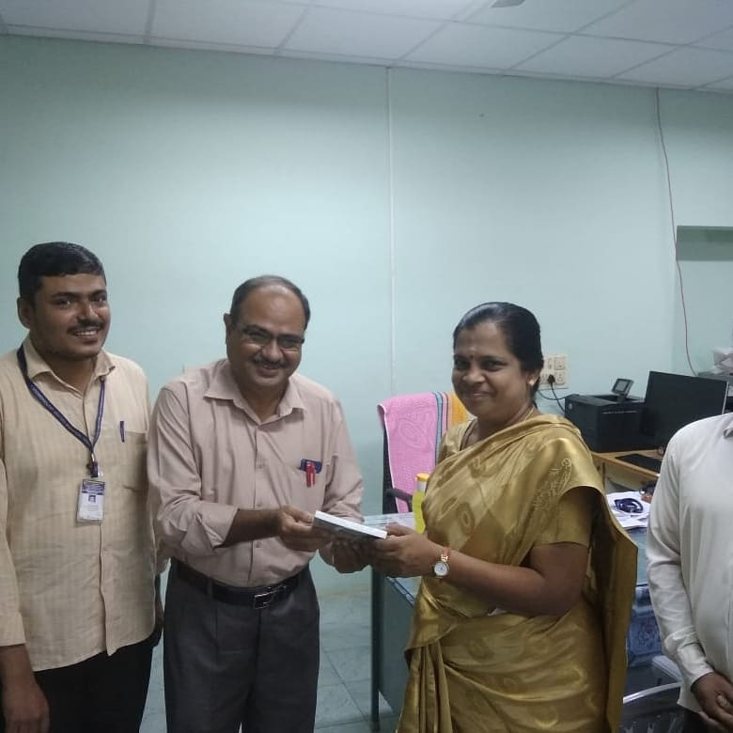

FIT INDIA MOVEMENT 2020 WALKATHON
On the date of 18/01/2020 NDIA CONSITUTION DAY was QUIZ COMPETITION The programme was a mass success because of the co-ordinator of volunteers
NO. OF PARTICIPANT : 05 DATE : 18/01/2020
VENUE : JMC
HOURS :1 hr TIME : 12:00AM to 1:00 PM

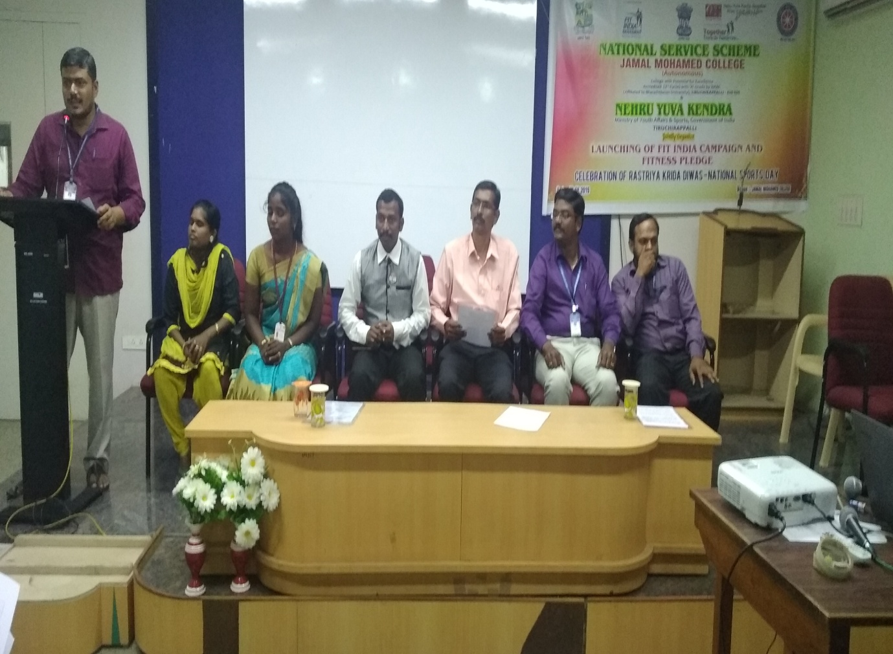

NSS AWARD CERMONY FUNCTION
On the date of 29/01/20, NSS AWARD CERMONY FUNCTION was conducted by the NSS VOLENTEER’S in BDU.

NO. OF PARTICIPANT: 35 DATE : 29/01/20
HOUR: 5 hrs TIME : 9:00 AM TO 2:00PM

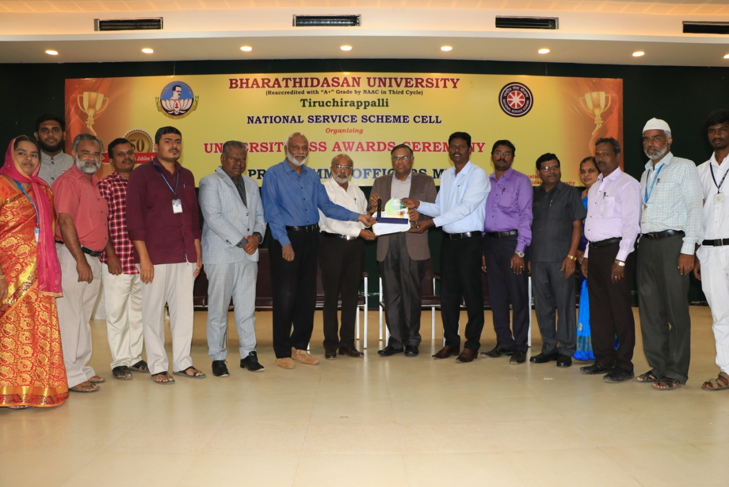
10th indian student parliament–
new DELHI,2020
I participated in INDIAN STUDENT PARLIAMENT CAMP which was held in New Delhi on 20-02-2020 to 23-02-2020 along with NSS Volunteers.
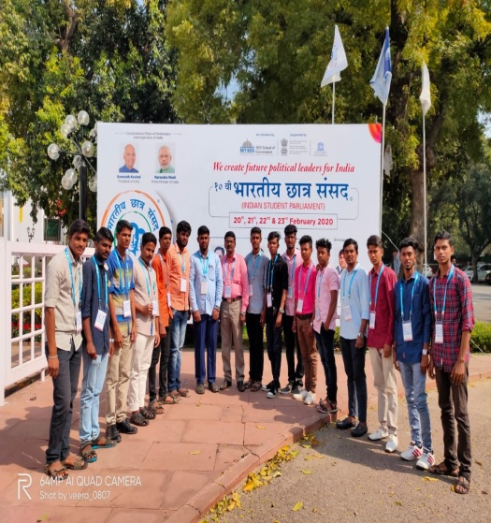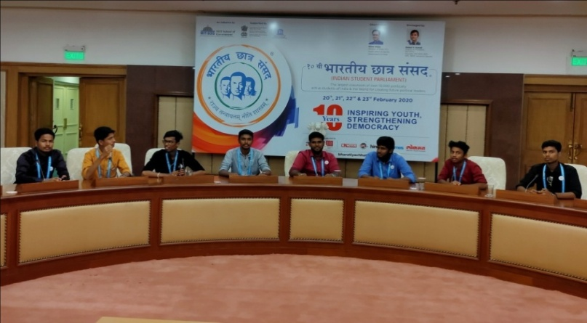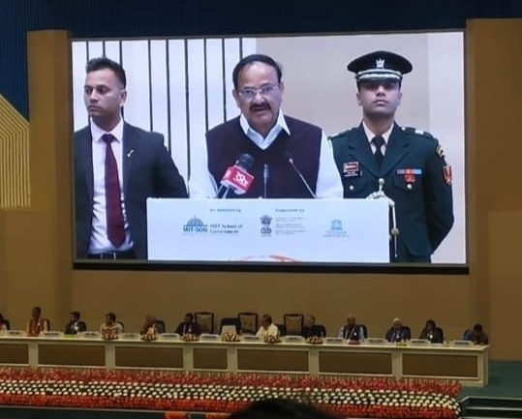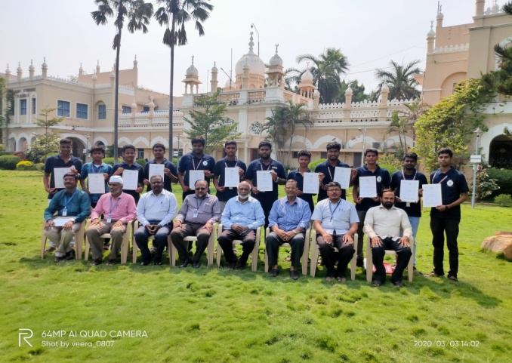

NSS ORIENTATION COURSE
I have undergone the General NSS Orientation Course conducted by Empanelled Training Institution, MSSW at BDU on
17-07-2019 to 23-07-2019.

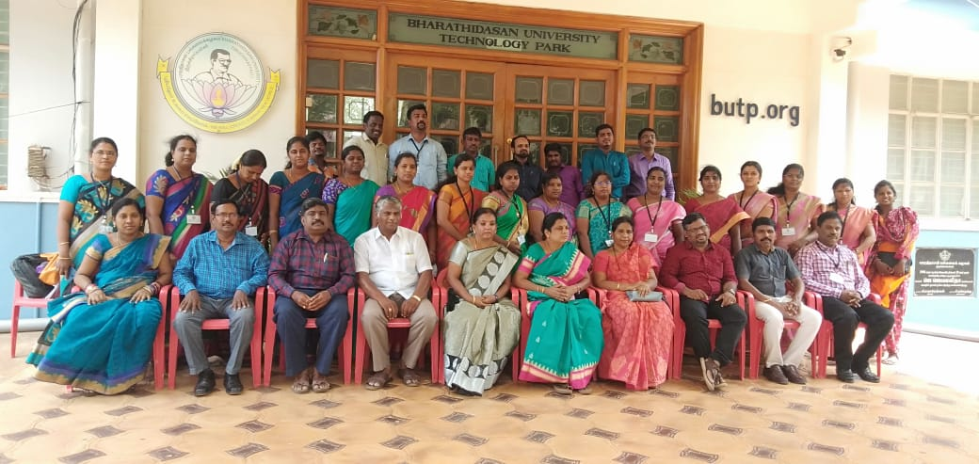

NSS AWARD
I have received Golden Service Award for the year 2019-2020 from NSS, Jamal Mohamed College, Trichy.

